# Introduction:

## Overview of the Project :

This project automates the deployment of a three-tier application using AWS CloudFormation. It provisions VPCs, subnets, route tables, and internet gateways while enabling VPC peering for inter-VPC communication. EC2 instances are launched to host the application, ensuring scalability and security. A Blue-Green Deployment strategy is implemented using identical EC2 instances to minimize downtime during updates. Code Deploy and Code Pipeline automate application updates for seamless deployments. An Auto Scaling group is configured to manage instance scaling based on demand. Route 53 is used to route traffic to the public instance IP for efficient access. Security groups and IAM roles ensure secure access control and permissions.

CloudWatch monitors logs and metrics for system health and performance. The infrastructure is fully automated and scalable for high availability and reliability.

## Problem statement :

Develop a weather application that allows users to check real-time weather for any city using a public weather API. Host the application on AWS EC2 instances and automate deployment using Code Deploy and Code Pipeline. Implement a CI/CD pipeline for seamless application updates and scalability.

## Objectives :

* Develop a weather application that fetches real-time weather data for any city using a public API.
* Deploy the application on AWS using EC2 instances for hosting.
* Automate the deployment and updates using AWS CodeDeploy and CodePipeline.
* Ensure high availability, scalability, and reliability of the application.
* Implement monitoring and logging using AWS CloudWatch for performance tracking.

## Goals :

* Provide users with an easy-to-use interface for checking weather updates.
* Automate the CI/CD process for seamless application deployment and updates.
* Utilize AWS best practices for infrastructure management and deployment.
* Ensure minimal downtime and quick rollback in case of deployment failures.
* Optimize performance and security of the deployed application.

# Project Architecture :

## High – level Architecture Diagram:

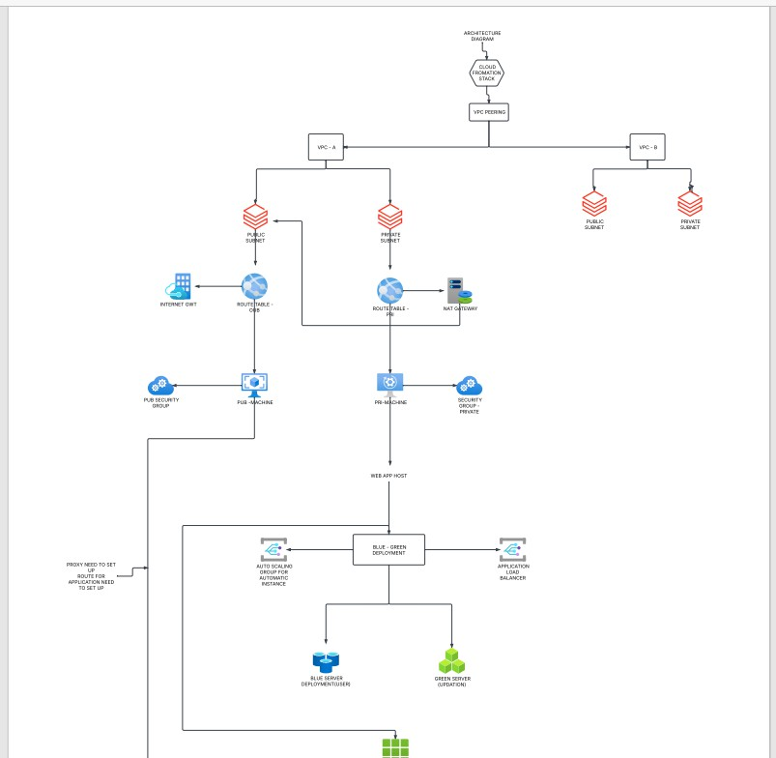

The architecture diagram illustrates the deployment of the weather application on AWS, featuring EC2 instances for hosting, S3 for storing assets, and Route 53 for domain management. It also includes a CI/CD pipeline using CodeCommit, CodeBuild, CodeDeploy, and CodePipeline for automated deployment and updates.

## AWS Services Used :

### Compute & Scaling:

* + - **EC2 (Elastic Compute Cloud):** Hosts the weather application (Frontend & Backend).
    - **Auto Scaling Group (ASG):** Automatically scales EC2 instances based on traffic.
    - **Application Load Balancer (ALB):** Distributes incoming traffic to backend instances.

### Storage:

* + - **S3 (Simple Storage Service):** Stores deployment artifacts and static assets.

### Networking & Domain Management:

* + - **Route 53:** Manages the domain name and traffic routing.
    - **VPC (Virtual Private Cloud):** Provides a secure network for EC2 instances.
    - **Internet Gateway:** Enables public access to the application.
    - **NAT Gateway (Optional):** Allows private instances to access the internet.

### CI/CD & Deployment Automation:

* + - **Code-Commit:** Stores the application's source code.
    - **Code-Build:** Builds and packages the application.
    - **Code-Deploy:** Automates deployment of updates to EC2 instances.
    - **Code-Pipeline:** Orchestrates the CI/CD workflow.

### Monitoring & Logging:

* + - **CloudWatch:** Monitors logs, performance, and alerts.
    - **SNS (Simple Notification Service) (Optional):** Sends deployment notifications.

### Database (Optional):

* + - **RDS (Relational Database Service):** Stores historical weather data (if required).

### Application Components:

* + - **Frontend (React/HTML/CSS):** User interface for entering city names and displaying weather data.
    - **Backend (Node.js + Express):** Handles API requests and fetches weather data from Weather API.
    - **Weather API (e.g., Open Weather Map, Weather API):** Provides real-time weather data.

## Workflow-Explanation:

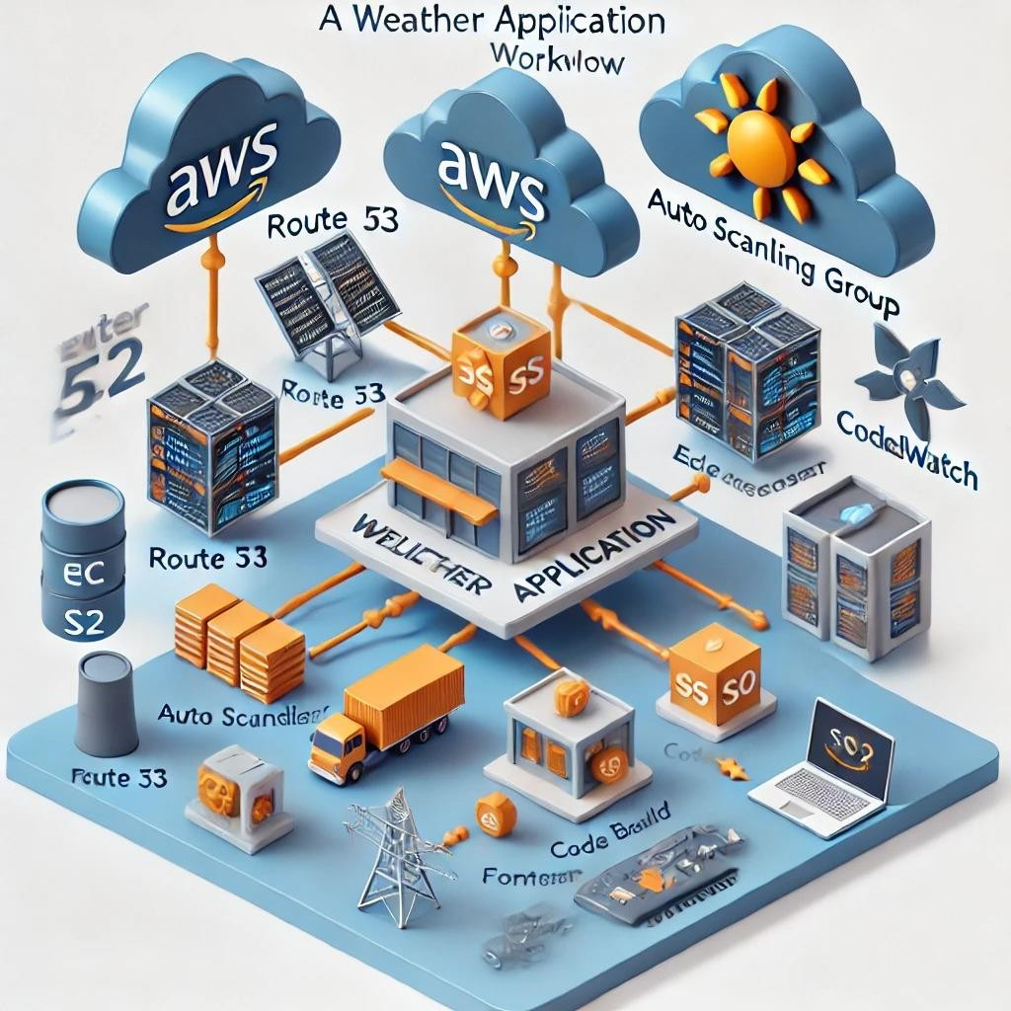

The **AWS architecture workflow** for the weather application begins with a user accessing the application through the internet. The **Route 53** service manages domain name resolution and routes the request to the **Application Load Balancer (ALB)**, which distributes traffic across multiple EC2 instances in an **Auto Scaling Group (ASG)**. The frontend, built with **React/HTML/CSS**, interacts with the backend, developed in **Node.js/Express**, which processes user requests. The backend fetches real-time weather data from an external **Weather API** (e.g., OpenWeatherMap). Static assets, such as images and scripts, are stored in **S3** for efficient access.

For automated deployments, the **CI/CD pipeline** uses **CodeCommit** for source code storage, **CodeBuild** for compiling the application, and **CodeDeploy** for pushing updates to EC2 instances. The entire process is orchestrated by **CodePipeline**, ensuring seamless application updates. **CloudWatch** is integrated for monitoring logs, performance metrics, and alerting potential issues. This architecture ensures **scalability, high availability, and automated deployments**, making the weather application reliable and efficient.

# Infrastructure Setup (Cloud Fromation) :

CloudFormation allows you to define your AWS infrastructure as code using a YAML or JSON template. Below are the steps to create a **VPC, public and private subnets, route tables, an Internet Gateway, and a NAT Gateway** using CloudFormation.

***Step 1: Create a CloudFormation Template***

* 1. Define the VPC
  2. Create Public and Private Subnets
  3. Set Up Route Tables (Public and Private)
  4. Attach an Internet Gateway to the VPC
  5. Associate Public Subnet with the Public Route Table
  6. Create an Elastic IP for the NAT Gateway
  7. Launch a NAT Gateway in the Public Subnet
  8. Associate the Private Subnet with the Private Route Table (Using NAT Gateway)

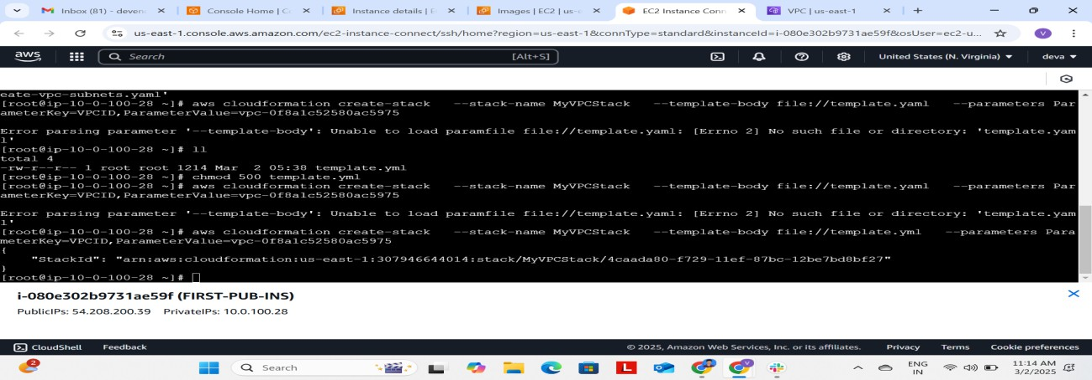

We need to create template and attach that template to the stack that we create in the desination of file.

[root@ip-10-0-100-28 ~]# cat vpc.yaml AWSTemplateFormatVersion: '2010-09-09'

Resources:

# VPC Creation MyVPC:

Type: AWS::EC2::VPC

Properties:

CidrBlock: "10.0.0.0/16" EnableDnsSupport: true EnableDnsHostnames: true Tags:

- Key: Name Value: "MyVPC"

# Public Subnet PublicSubnet:

Type: AWS::EC2::Subnet Properties:

VpcId: !Ref MyVPC CidrBlock: "10.0.100.0/24"

AvailabilityZone: !Select [ 0, !GetAZs '' ] MapPublicIpOnLaunch: true

Tags:

- Key: Name

Value: "Public Subnet"

# Private Subnet

PrivateSubnet:

Type: AWS::EC2::Subnet Properties:

VpcId: !Ref MyVPC CidrBlock: "10.0.200.0/24"

AvailabilityZone: !Select [ 1, !GetAZs '' ] MapPublicIpOnLaunch: false

Tags:

- Key: Name

Value: "Private Subnet"

# Internet Gateway for Public Subnet Access InternetGateway:

Type: AWS::EC2::InternetGateway Properties:

Tags:

- Key: Name

Value: "MyInternetGateway"

# Attach Internet Gateway to VPC AttachInternetGateway:

Type: AWS::EC2::VPCGatewayAttachment Properties:

VpcId: !Ref MyVPC

InternetGatewayId: !Ref InternetGateway

# Route Table for Public Subnet PublicRouteTable:

Type: AWS::EC2::RouteTable Properties:

VpcId: !Ref MyVPC Tags:

- Key: Name

Value: "PublicRouteTable"

# Public Route to Internet Gateway PublicRoute:

Type: AWS::EC2::Route Properties:

RouteTableId: !Ref PublicRouteTable DestinationCidrBlock: "0.0.0.0/0"

GatewayId: !Ref InternetGateway

# Associate Public Route Table with Public Subnet PublicSubnetRouteTableAssociation:

Type: AWS::EC2::SubnetRouteTableAssociation Properties:

SubnetId: !Ref PublicSubnet RouteTableId: !Ref PublicRouteTable

Outputs: VPCID:

Description: "The ID of the created VPC" Value: !Ref MyVPC

PublicSubnetID:

Description: "The ID of the public subnet" Value: !Ref PublicSubnet

PrivateSubnetID:

Description: "The ID of the private subnet" Value: !Ref PrivateSubnet

InternetGatewayID:

Description: "The ID of the internet gateway" Value: !Ref InternetGateway

This creates a stack in the cloud formation for VPC , SUBNETS and ROUTE TABLES, INTERNET GATEWAYS.

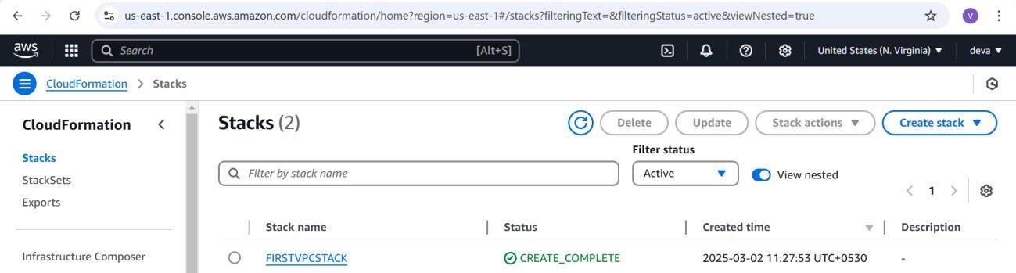

By creating this stack we can get the VPC and two subnets with the CIDR blocks(10.0.100.0/24) and (10.0.200.0/24) with another block these are the private and public subnets and Routetables are also created one for public route table and one for private route table and the Internet gateway is also created.

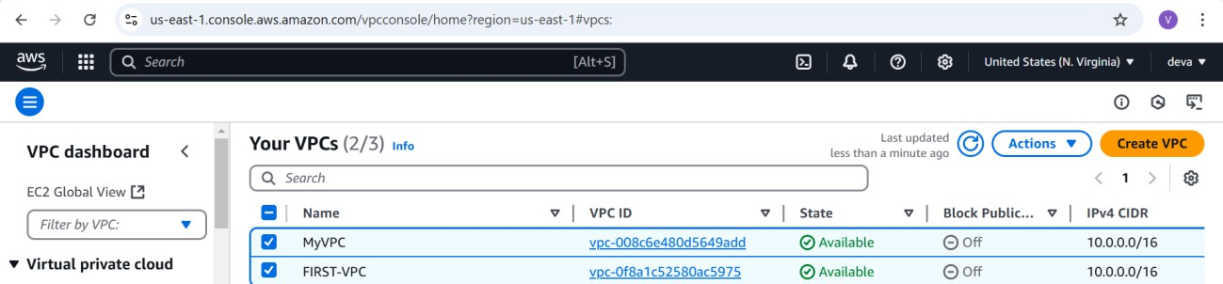

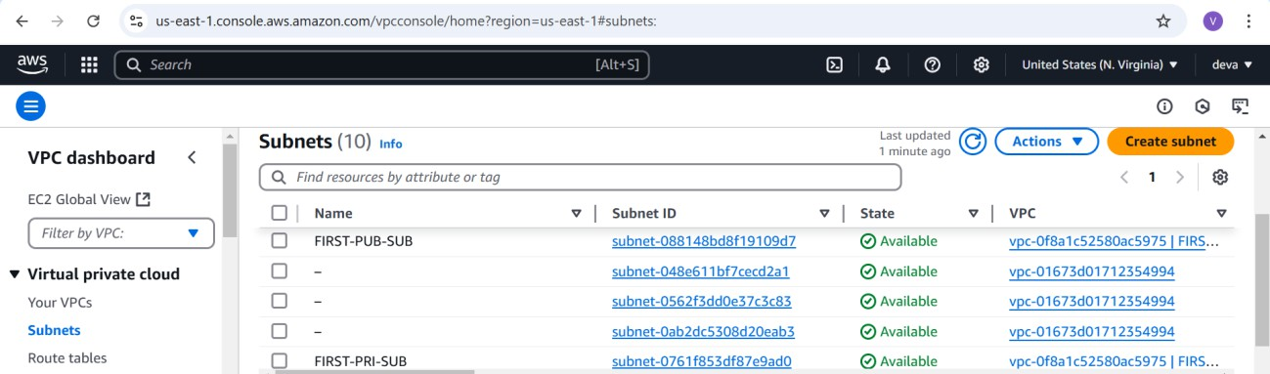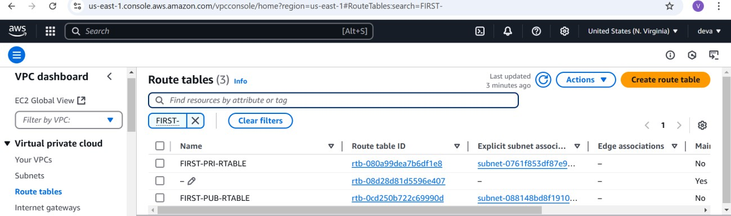

After creating the stack you should get these VPC and subnets and route tables in the aws console and if any errors you face try to configure them properly. And try to watch event logs in the cloud Formation so , that you can figure out them.

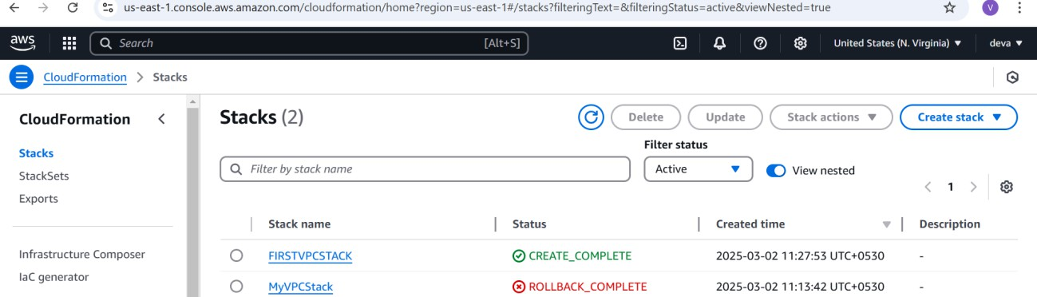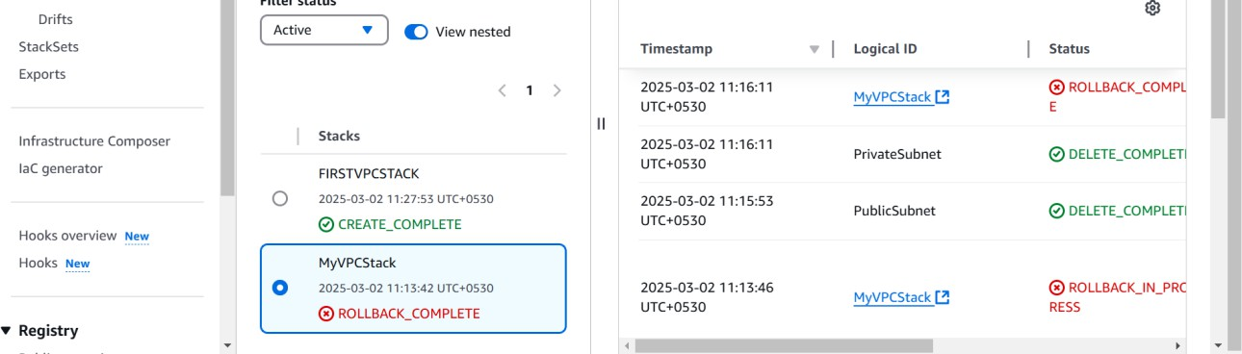

By using the event log details you can get to know the where the mistake is held and form where you can get rectify that to solve the configuration for the template, you need to do this.

## Development instances configuration:

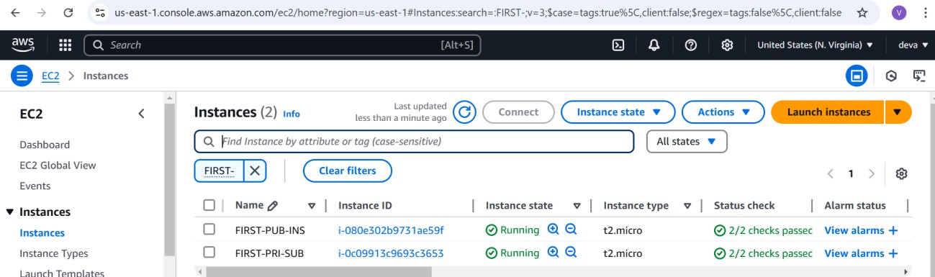

These are the instances created by the cloud formation stack and these instances are belong to the Green-Deployment server where the application development has been done.

The security groups attached to this instaces are :

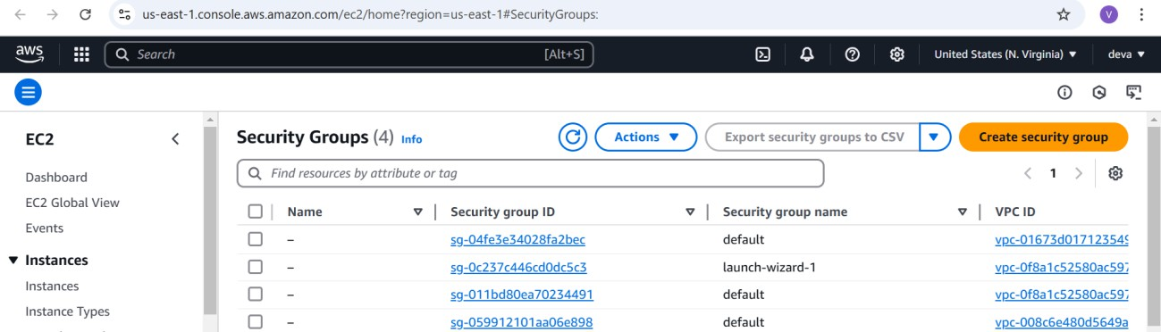

The protocols allowed for this instance securtiy groups are ALL TCP for Public instace and for the private instance security group in public instance security group.

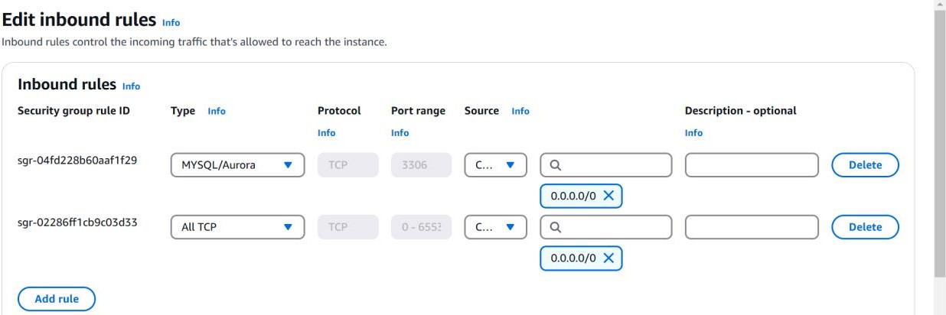

For the Green development private instance the security group is attached is public instance security group and this should allow only the users who comes with the public instance of VPC FIRST.

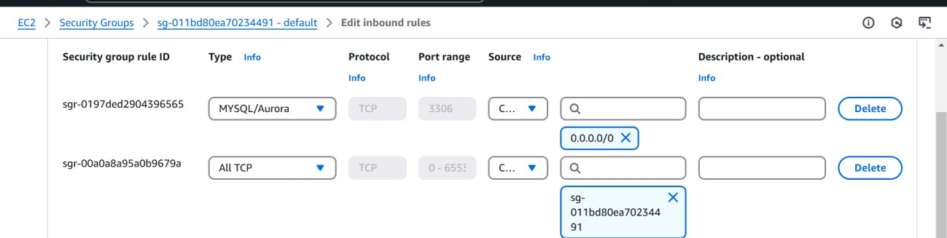

For all tcp the security gorup is mentioned as the public instance subnet group form only that subnets users can enter in to this private instance application

Allow t2.micro , SSH KEY-PAIR : AMA-LIN.pem.

Open the public instance in the public subnet and create frontend application of the weather – app that you need to display as the output for the user in the browser.

After connecting the public intsance we need to configure the IAM user to access cli and create the files and to send the files to the s3 storage.

# Step 1: Sign in to AWS IAM Console

## Go to AWS Management Console

* 1. Open the AWS Console: [AWS IAM Console](https://console.aws.amazon.com/iam)
  2. Sign in as an **Administrator**.

## Navigate to IAM

* 1. In the AWS Management Console, search for **IAM** and open it.
  2. On the left panel, click **Users**.

# Step 2: Create a New IAM User

1. Click **"Add users"**.
2. Enter a **User name** (e.g., MyIAMUser).
3. Choose **AWS access type**:
   1. **Programmatic access** → If the user needs an **Access Key & Secret Key** for CLI, SDK, or API access.
   2. **AWS Management Console access** → If the user needs access to the **AWS Console**.
   3. (You can enable both if needed).
4. If enabling **AWS Management Console access**:
   1. Choose **Auto-generated password** or set a custom password.
   2. Optionally, enforce **password reset on first login**.

# Step 3: Assign Permissions

Choose how to assign permissions to the user:

1. **Attach existing policies directly** (Recommended)
   1. Select pre-defined AWS policies like:
      1. **AdministratorAccess** → Full access
      2. **PowerUserAccess** → Access without IAM permissions
      3. **AmazonS3FullAccess** → Full access to S3
      4. **AmazonEC2FullAccess** → Full access to EC2
2. **Add user to a group** (if groups are already created).
3. **Copy permissions from an existing user** (optional).
4. **Attach custom policies** (for specific permissions).

Click **Next**.

# Step 4: Review & Create

1. Review the user details and permissions.
2. Click **"Create user"**.

# Step 5: Get User Credentials

1. The user is now created successfully.
2. If **programmatic access** is enabled, download the **Access Key ID & Secret Access Key**

(store it securely).

1. If **AWS Management Console access** is enabled, share the **login URL and credentials**

with the user.

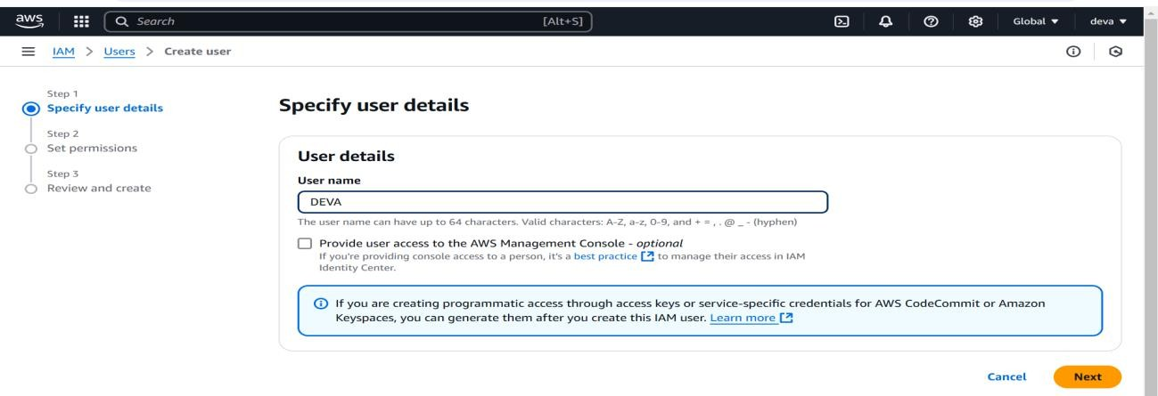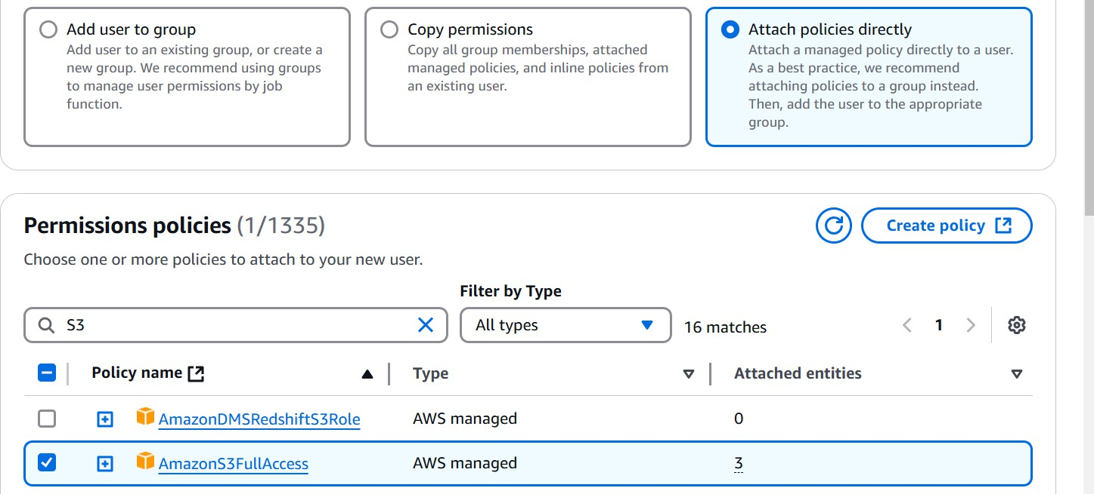

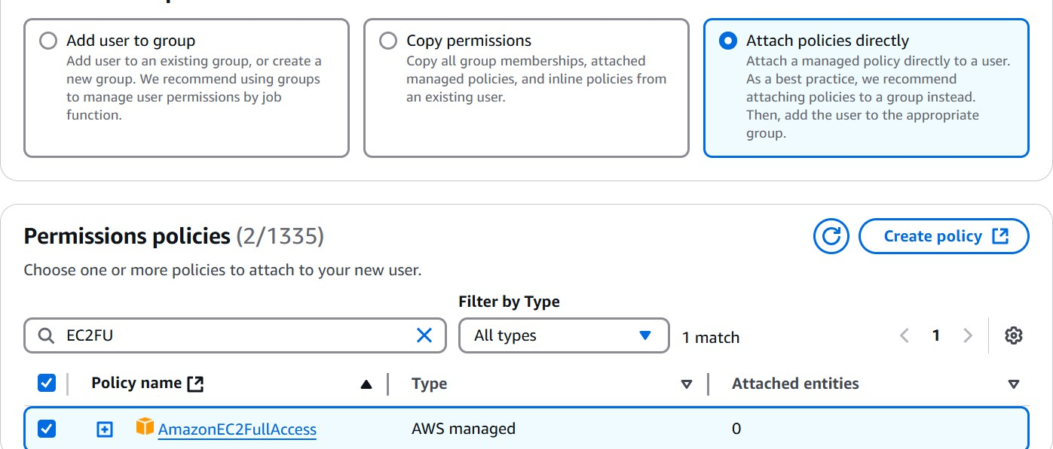

These are the two policies that we need to attach to the user to specify the permissions that we need to give for the user to access the services.

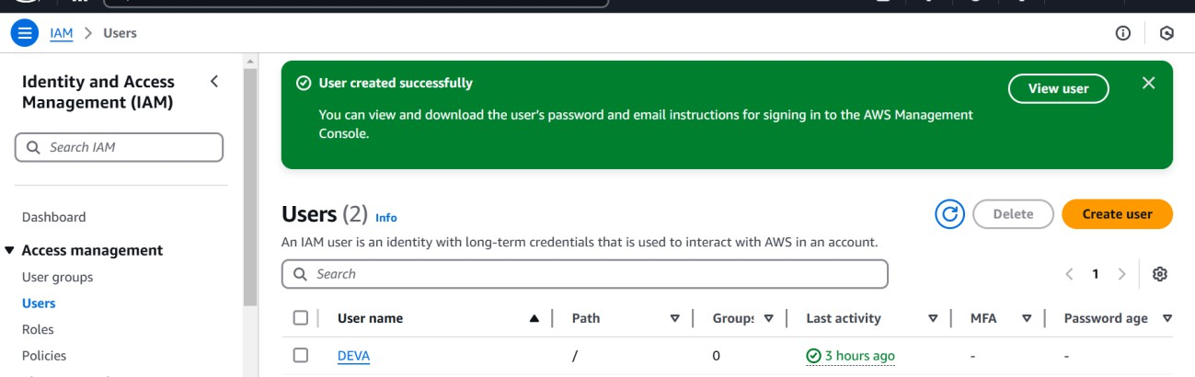

After creating user we need to create the access key and security key for the user so then only we can access the aws through cli for implementing all the files in the fornt end and designing the web application.

Click on the user you created and open the security and credentials tab and click on the create access key and choose Command line interface and click next and create access key for the use.

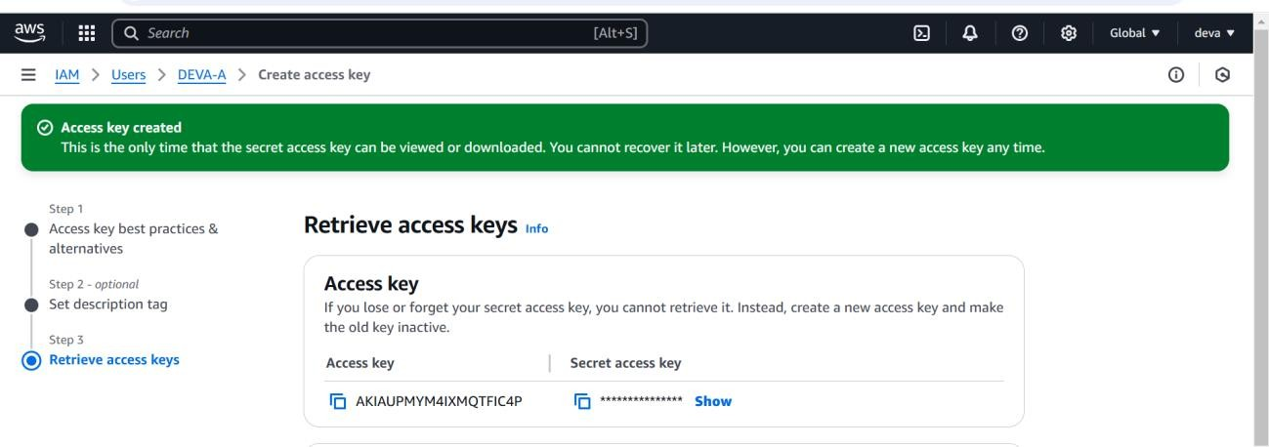

The command that we use to configure the iam user in the linux machine is ;

## Command : aws configure

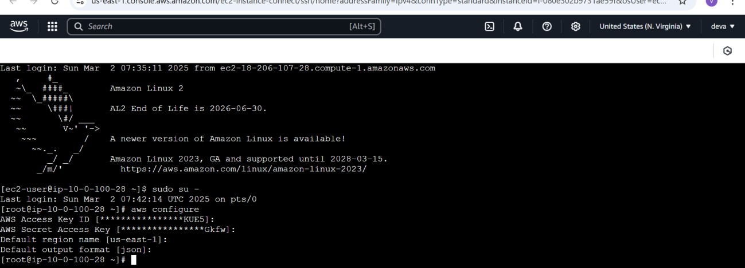

Enter the access and secret key of the iam user then the user will be registered and the control for the access comes.

We need to create the main directory for the all the files and i created the folder as follows; Commands :

1. Mkdir /var/www/weather-app
2. cd /var/www/weather-app
3. Mkdir index.html
   * 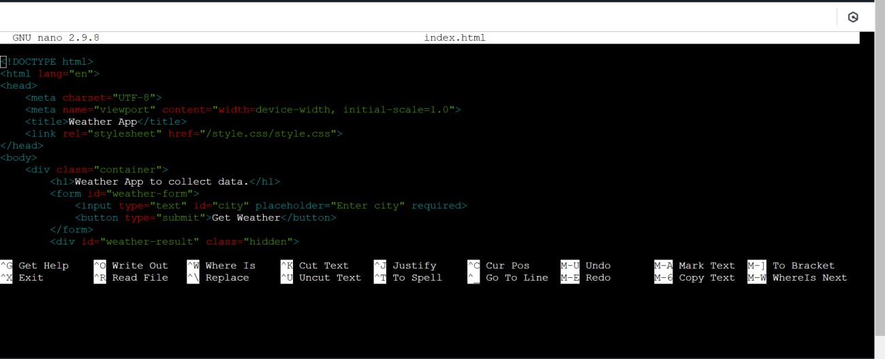Nano index.html

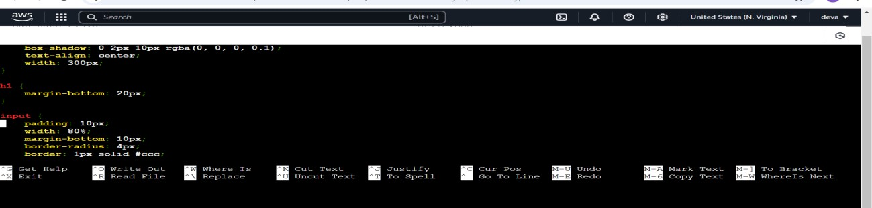

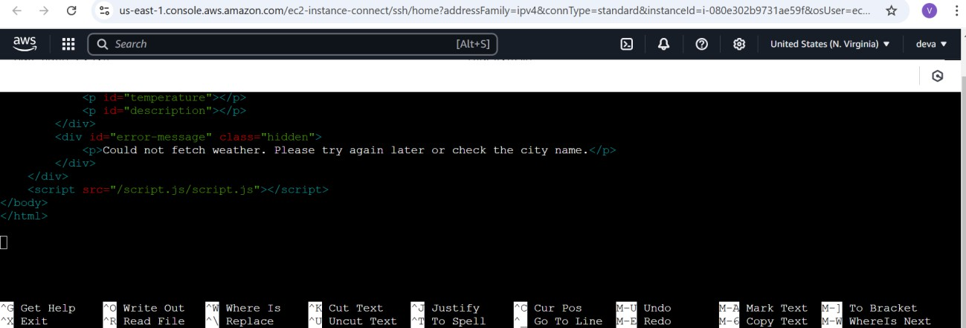After creating this index.html try to add the css file for this index.html to create the styling for this file and to make it interactive more.

1. Mkdir style.css
2. Cd style.css
   * 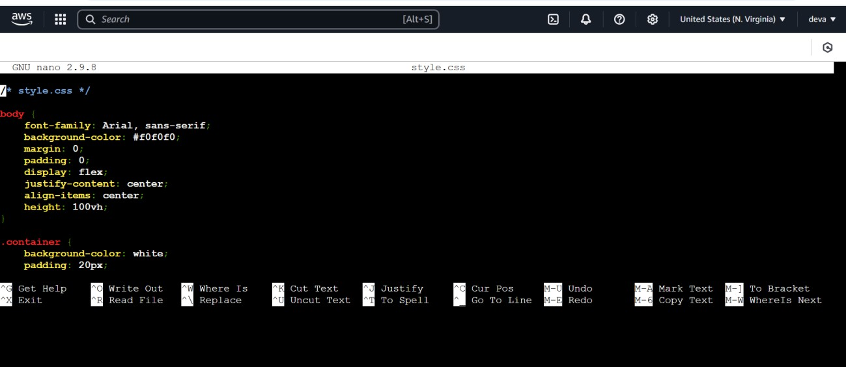Style.css

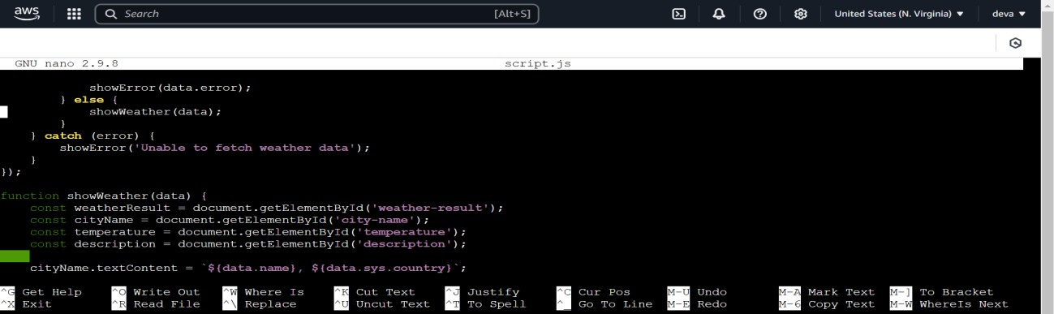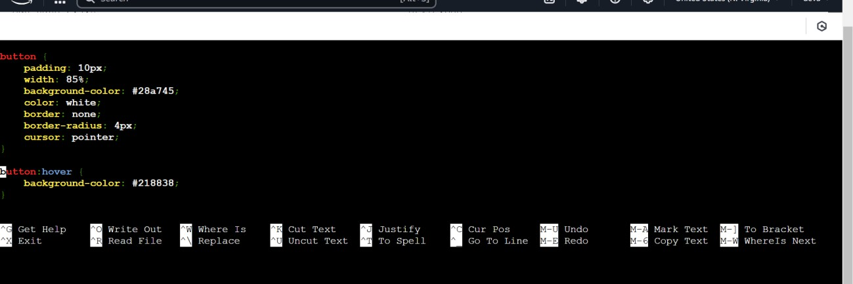

After creating this we need to create the dynamic functionality for this front end what we did and to achieve that functionality we need to set up the java script file in this front end application so that we can bring that functionality and the js file in my app is looks like this;

## Mkdir script.js Cd script.js Nano script.js

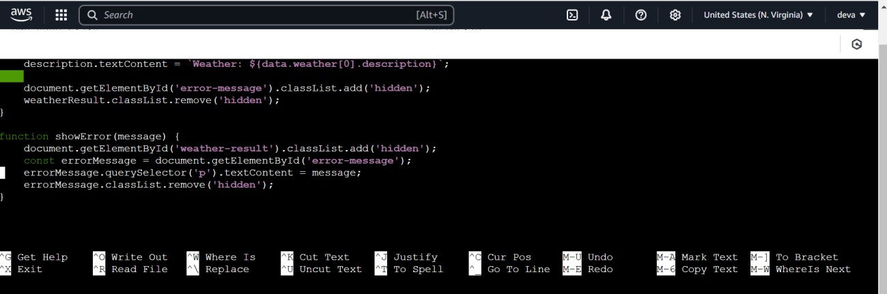By doing all these files and connecting links for all these files in the index.html file it allows the styling and javascript dynamic functionality for the fornt end application so, that we can able to see the output in the browser.

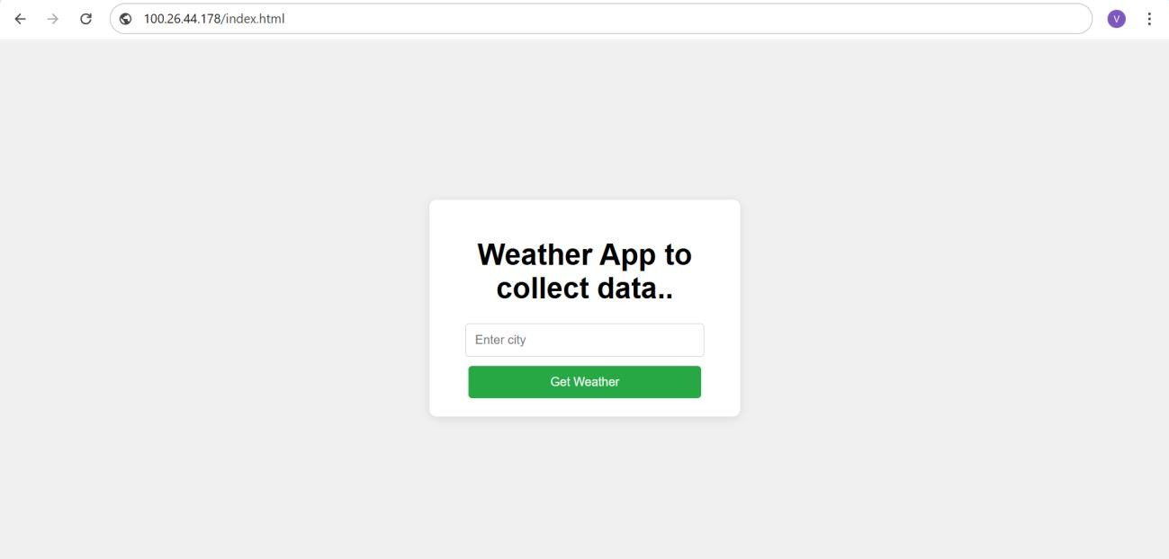Copy and paste the public ip address of this instance so that we can get the output of this.

After doing all these steps in the public instance we need to connect the private instance to the public instance by using ssh and winscp .

Before connecting private instance form public machine we need to ensure the pem and ppk file present in the winscp so that we can use the command to connect to the private instance.

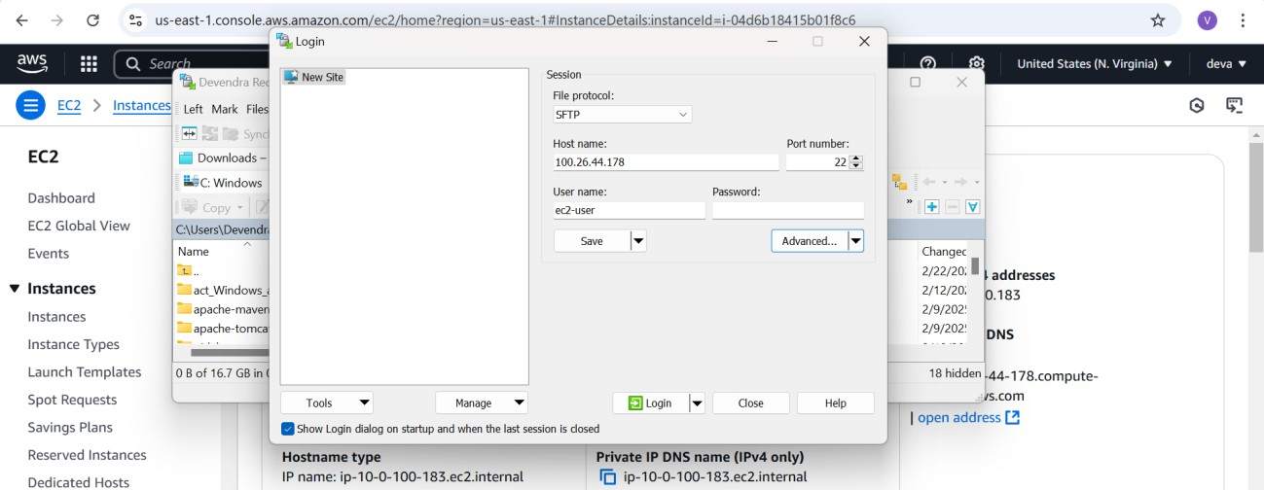

## Steps to Connect a Private EC2 Instance via a Public EC2 Instance (Bastion Host)

1. **Launch a Public EC2 Instance** in a public subnet with a public IP.
2. **Launch a Private EC2 Instance** in a private subnet without a public IP.
3. **Ensure Both Instances Are in the Same VPC** for internal communication.
4. **Attach a Security Group to the Private Instance** allowing SSH access only from the Public Instance.
5. **Attach a Security Group to the Public Instance** allowing SSH access from your local machine.
6. **Connect to the Public Instance** using SSH from your local machine:

## Command : ssh - i /home/ec2-user/AMA-LIN.pem [ec2-user@10.0.200.70](mailto:ec2-user@10.0.200.70)

After entering this command the public instance should connect to the private instance (Green enviroment which is for development).

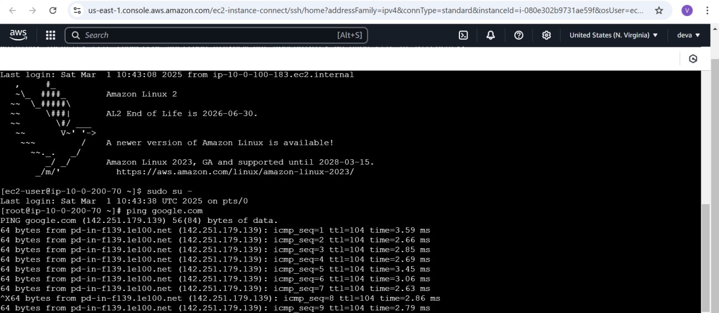

Now, we are connected to the private instance and we can able to ping the **google.com** as well that is conformation that we are getting internet on this instance.

We need to create a directory for the backend of the weather website to get the information of the weather from the api when we call weather route form the java script through **fetch api** it needs to display the weather form the backend.

**Commands :**

1. **mkdir weather-backend**
2. **cd weather-backend**

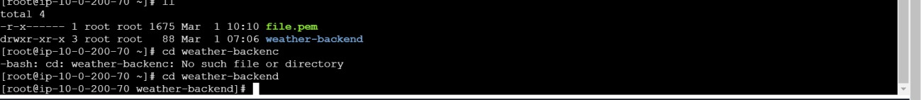

We need to install the necessary libraries and modules which are required for the applications to develop and create the server for the backend development for our weather-website.

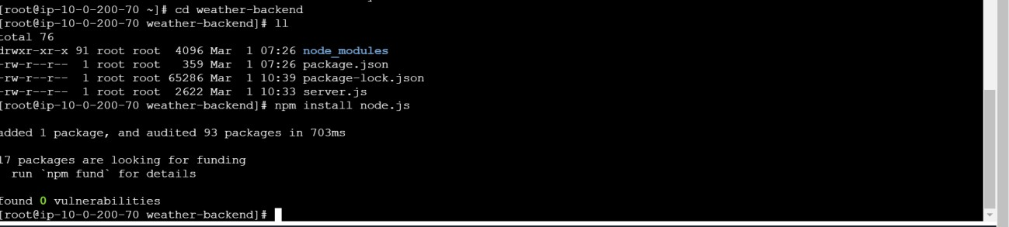

We can see the list of modules and packages that we have installed in our application to create the server and to fetch the details of the application from that server.

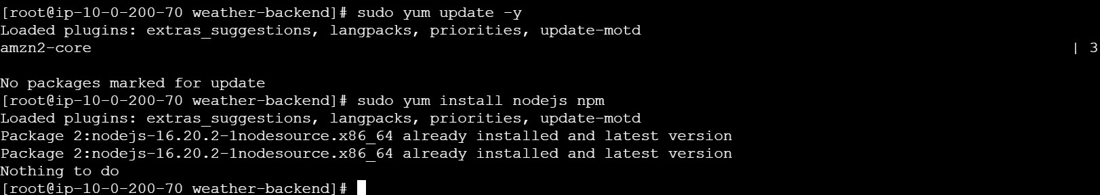

You need to see this versions of the nodejs and npm if they are installed and using in the application.

We are alos need to install other packages also for creating the server and to start that server they are **express , axios , dotenv , cors**

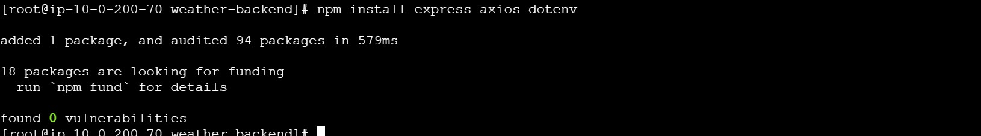

After downloading all these packages we are ready to build our server backend to communicate with the front end and retreive the data from the api and sends that data to the frontend to show the details in the fornt end user interface.

We need to create a server.js file in the backend of our website and in that server.js we need to define the code for our server to communicate with the api and retreive the data in the form of json.

## nano server.js

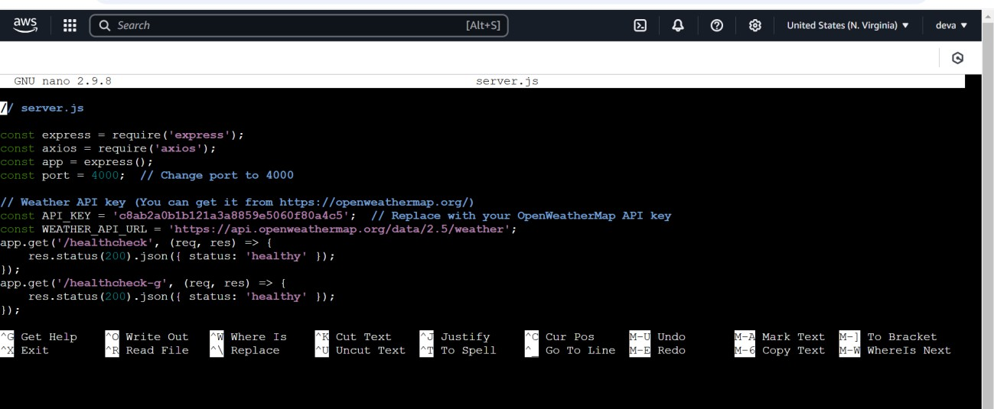

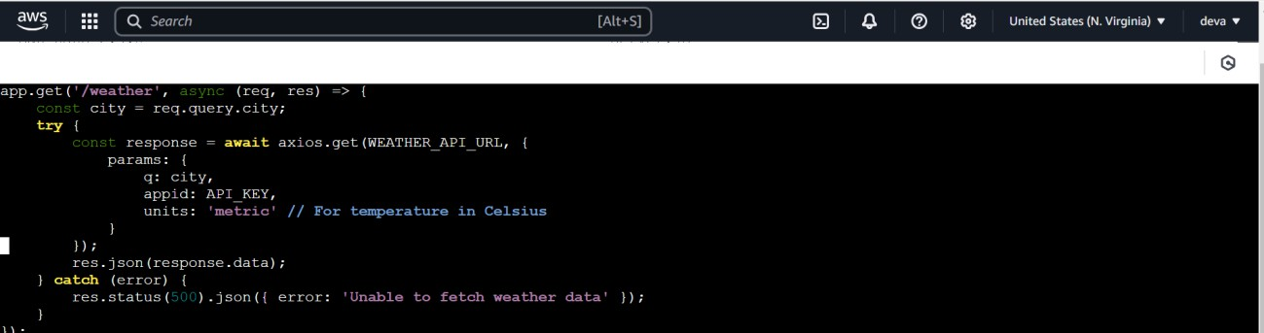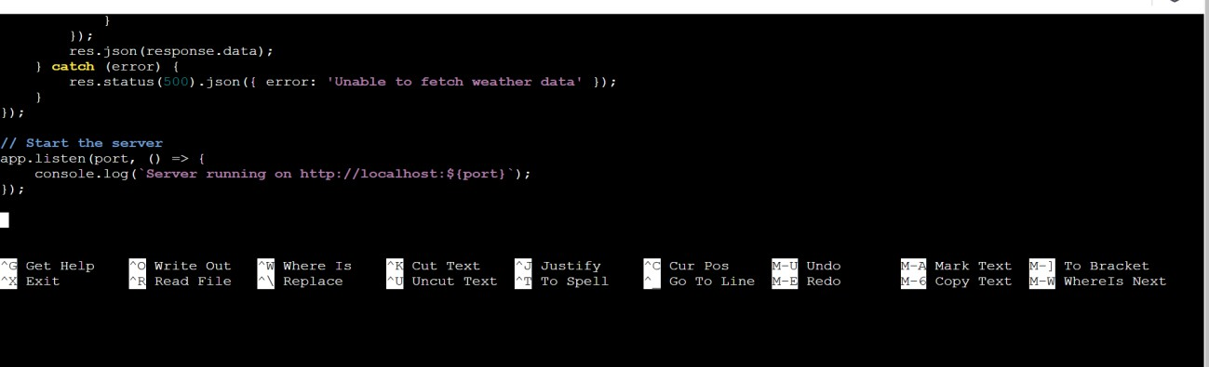

We need to run the command to start the server and listen to port and request the data from the api to send to the front end.

## Command : node server.js

When you run this command you will get to see the output in the cli as the server is running on the localhost 4000.



Our backend file is ready with source code to start our server and we need to connect this backend to our front end for that we need to set up the communication for our front end backend but the front end and backend of our application lies on the different instances to set up the connection for those instances we need to set up the proxy for the public instance to communicate to the private instance.

Setting up proxy for the public instance to communicate to the private instance.

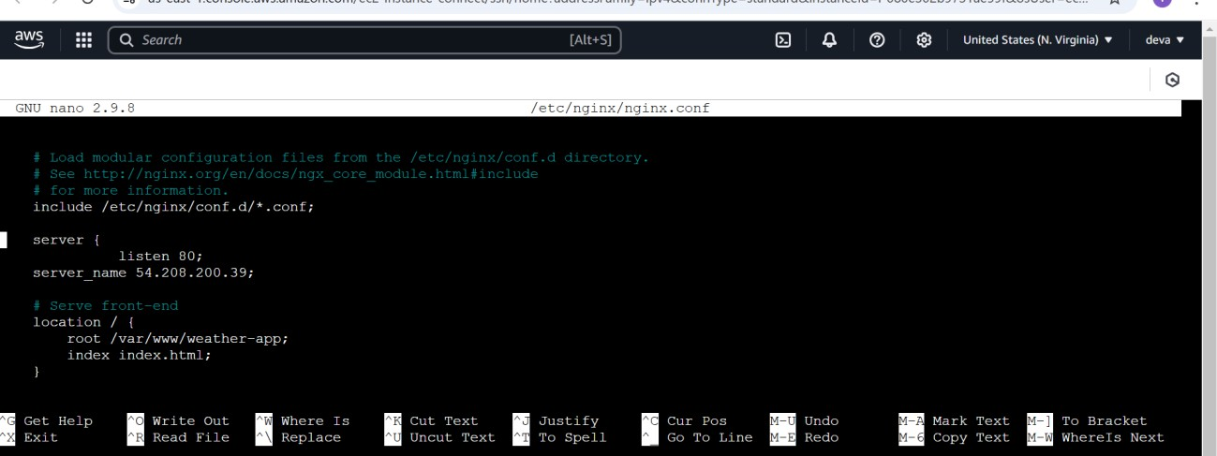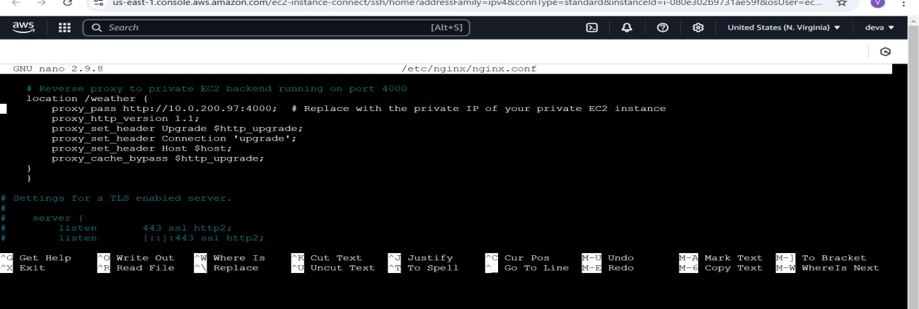

After setting up the proxy we can see the fornt end is able to communicate to the backend and we will get the desired output in the browser when we enter the city in the input box.

The next thing what we need to do is here we are creating a three tier web application (presentation layer , application layer , database layer) hence we need to build database here for the database prupose i am going to create RDS form the aws and to store the temperature and city data in the rds database and i will access that data form the console of the ec2 machine for any modifications and customiztions.

For that we need to create a vpc peering because i am connecting the database in the another vpc in different region in same account and i am creating the database in the private subnet instance of that vpc.

**Creating VPC , SUBNETS , ROUTE TABLES , INTERNET GATEWAYS in another**

**region (ohio).**

# Step 1: Create a VPC

1. Go to **AWS Console** → Open **VPC Dashboard**.
2. Click **"Create VPC"**.

## Enter VPC Details:

* 1. **Name:** SECOND-VPC
  2. **IPv4 CIDR:** 20.0.0.0/16
  3. **Tenancy:** Default

1. Click **"Create VPC"**.

# Step 2: Create a Public Subnet

1. In the **VPC Dashboard**, go to **Subnets** → Click **"Create subnet"**.

## Enter Subnet Details:

* 1. **VPC ID:** Select SECOND-VPC
  2. **Subnet name:** SEC-PUB-SUB
  3. **IPv4 CIDR:** 20.0.100.0/24
  4. **Availability Zone:** Select any AZ (e.g., us-east-1a)

3. Click **"Create subnet"**.

# Step 3: Create a Private Subnet

1. Click **"Create subnet"** again.

## Enter Subnet Details:

* 1. **VPC ID:** Select SECOND-VPC
  2. **Subnet name:** SEC-PRI-SUB
  3. **IPv4 CIDR:** 20.0.200.0/24
  4. **Availability Zone:** Select another AZ (e.g., us-east-1b)

3. Click **"Create subnet"**.

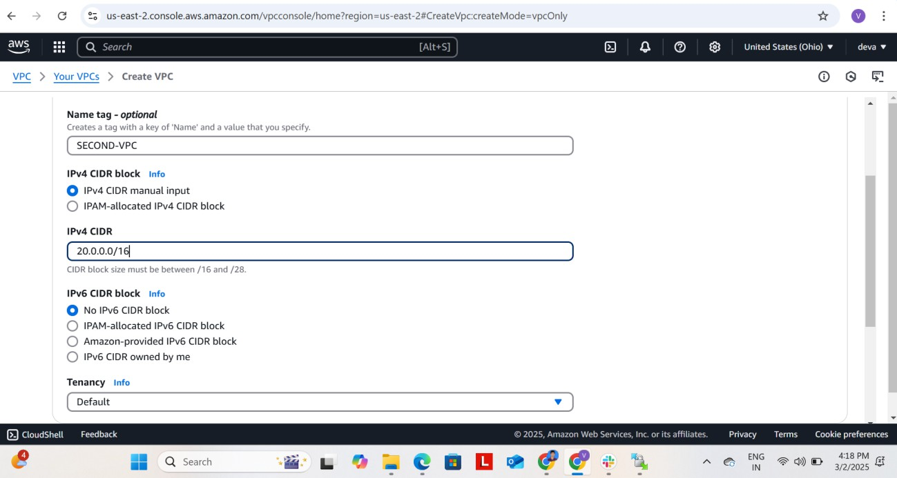

Click on the create vpc button that will create the vpc for you by the name given for that vpc and after creating vpc we need to create the subnets for that vpc public subnet and the private subnet.

Choose the vpc (second-vpc) that you have created and create the two subnets in that vpc and public and private subnets.

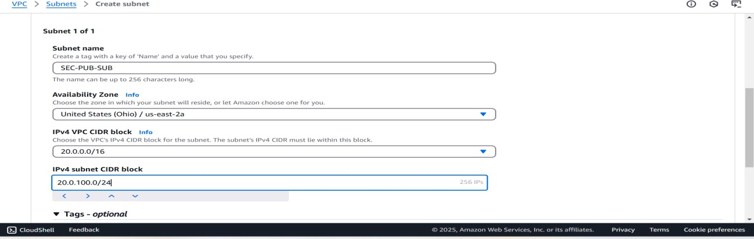

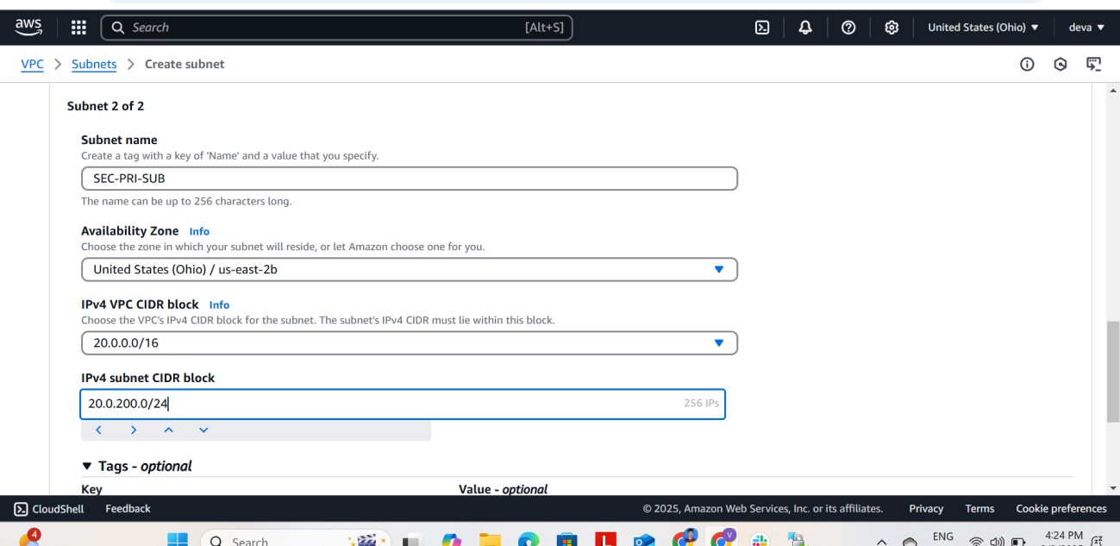

After creation of pub and private subnets we need to create the pub and private routetables for each subnet to attach them within the vpc.

# Step 4: Create an Internet Gateway (IGW) for Public Subnet

1. In the **VPC Dashboard**, go to **Internet Gateways** → Click **"Create internet gateway"**.
2. **Enter IGW Name:** MyIGW → Click **Create**.

## Attach to VPC:

* 1. Select MyVPC
  2. Click **"Attach Internet Gateway"**.

# Step 5: Create a Route Table for Public Subnet

1. Go to **Route Tables** → Click **"Create route table"**.

## Enter Details:

* 1. **Name:** Public-RT
  2. **VPC ID:** Select MyVPC

1. Click **Create**.
2. Select the created route table → **Go to Routes tab** → Click **Edit routes**.

## Add Route:

* 1. **Destination:** 0.0.0.0/0

## Target: Select Internet Gateway (MyIGW)

1. Click **Save changes**.

## Associate Public Subnet:

* 1. Go to **Subnet associations** → Click **Edit subnet associations**.
  2. Select Public-Subnet → Click **Save**.

# Step 6: Create a Route Table for Private Subnet (with NAT Gateway - Optional)

## Create a NAT Gateway

* 1. Go to **NAT Gateways** → Click **Create NAT Gateway**.
  2. **Subnet:** Select Public-Subnet.
  3. **Elastic IP:** Click **Allocate new Elastic IP** → Select it.
  4. Click **Create NAT Gateway**.

## Create Private Route Table

* 1. Go to **Route Tables** → Click **Create route table**.
  2. **Name:** Private-RT
  3. **VPC ID:** Select MyVPC
  4. Click **Create**.

## Add Route to Private Route Table

* 1. Select Private-RT → **Go to Routes tab** → Click **Edit routes**.

## Add Route:

* + 1. **Destination:** 0.0.0.0/0

## Target: Select NAT Gateway (MyNATGateway)

* 1. Click **Save changes**.

## Associate Private Subnet:

* 1. Go to **Subnet associations** → Click **Edit subnet associations**.
  2. Select Private-Subnet → Click **Save**.

# Step 7: Verify the Configuration

## Public Subnet should have Internet access.

1. **Private Subnet should access the internet only via NAT Gateway.**
2. **Test by launching EC2 instances** in public/private subnets and checking connectivity.

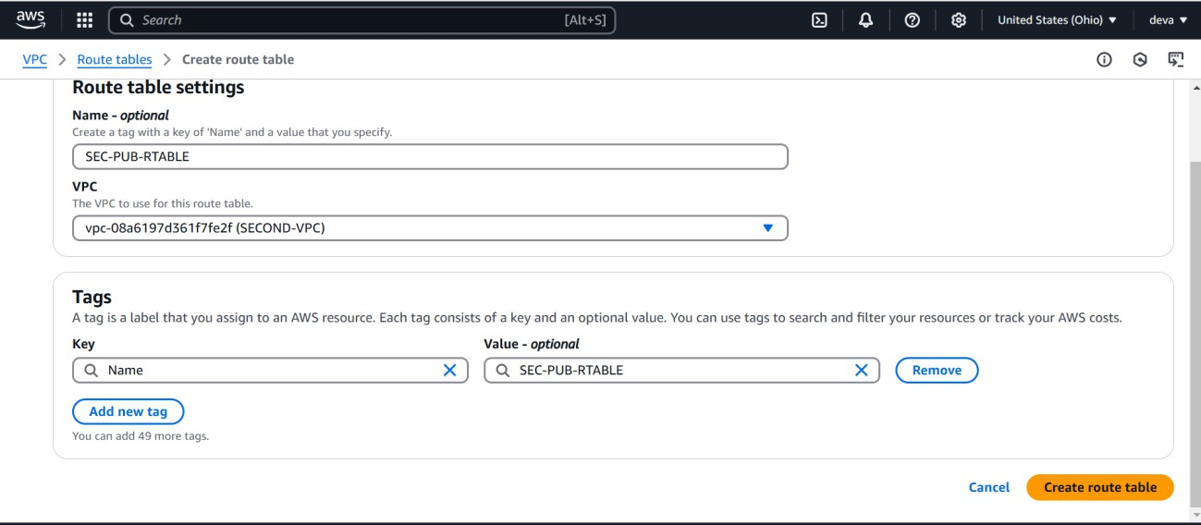

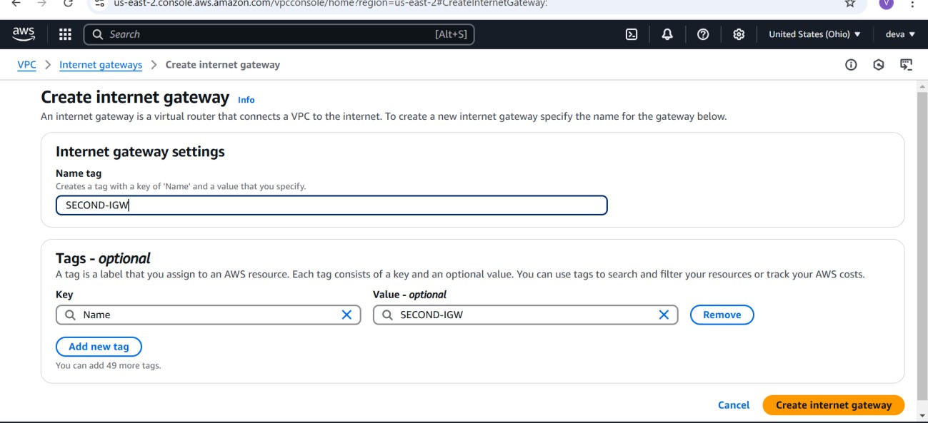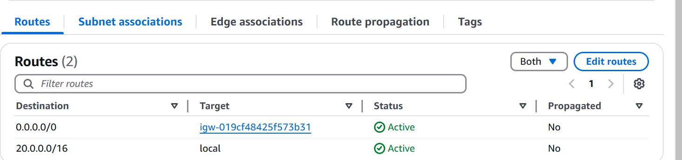

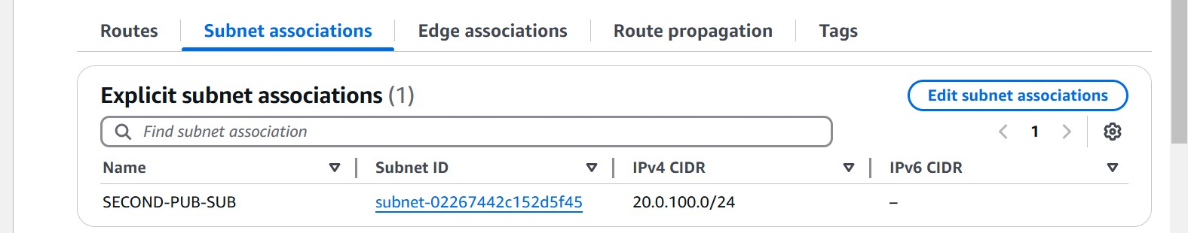

Public route table has been attached to the public subnet and internet gateway has been attached to the public subnet.

1. go to route tab in the public route table and click on edit routes.
2. attach internet gateway to thepublic route table.

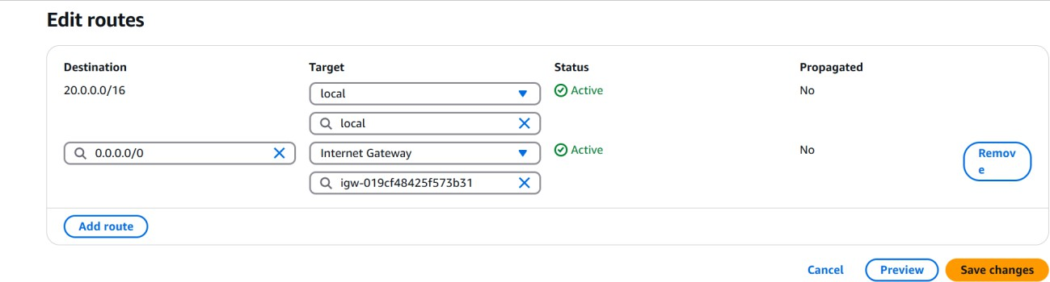

Attach private subnet to the nat gateway by creating that nat gateway and pass internet through the public subnet.

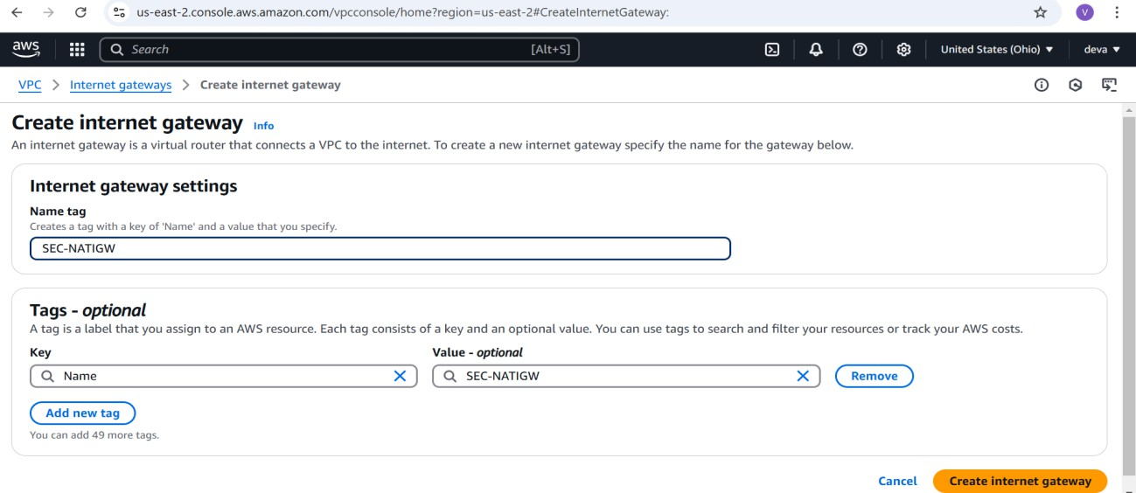

# Step 1: Go to Route Tables in AWS Console

* 1. Open the **AWS Console** → Go to **VPC Dashboard**.
  2. In the left panel, click **Route Tables**.
  3. Find the **Private Route Table** (created for the private subnet).
  4. Select the Private Route Table and click **Routes tab**.

# Step 2: Edit Routes in Private Route Table

1. Click **Edit Routes**.
2. Click **Add Route**.

## Enter the Destination:

* 1. **Destination:** 0.0.0.0/0 (for internet access from the private subnet)

## Select Target:

* 1. **Target:** Choose **NAT Gateway** from the dropdown.
  2. Select your **NAT Gateway (MyNATGateway)**.
  3. Click **Save Changes**.

# Step 3: Associate Private Subnet with Private Route Table

1. Click on the **Subnet Associations tab** in the Private Route Table.
2. Click **Edit Subnet Associations**.
3. Select the **Private Subnet** (20.0.200.0/24).
4. Click **Save**.

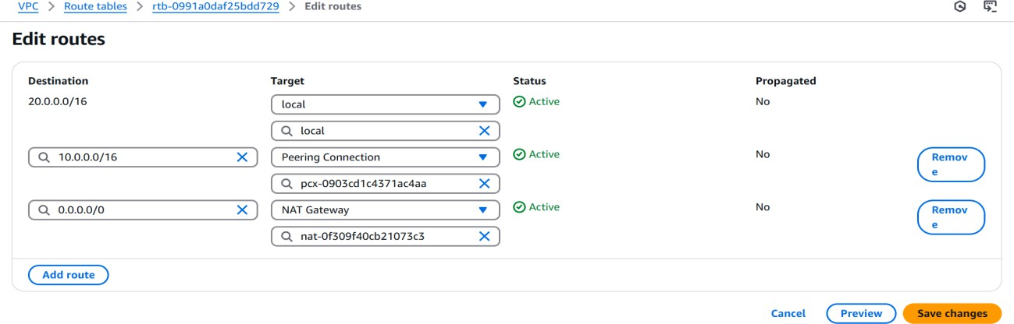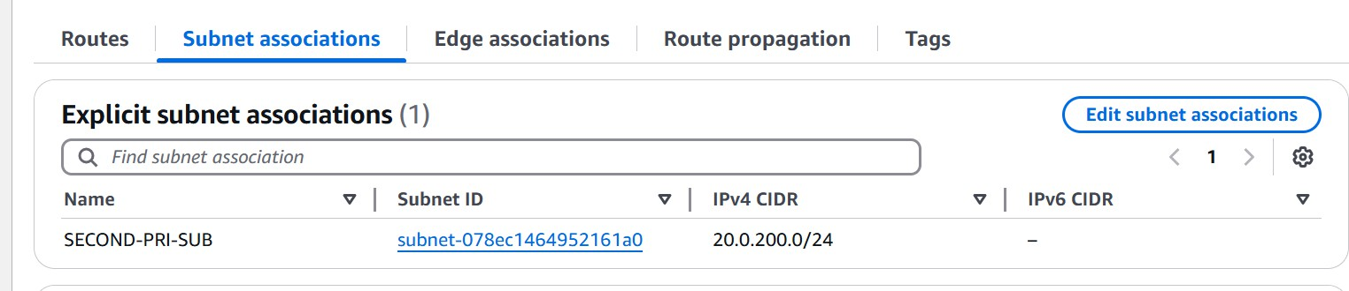

# Steps to Set Up VPC Peering Between VPC A and VPC B

VPC Peering allows communication between two VPCs using private IPs. Follow these steps to create a **VPC peering connection** between **VPC A (Requester)** and **VPC B (Accepter).**

# Step 1: Create VPC Peering Connection

* 1. Open the **AWS Console** → Go to **VPC Dashboard**.
  2. In the left panel, click **Peering Connections**.
  3. Click **Create Peering Connection**.

## Enter Details:

* + 1. **Peering connection name:** VPC-A-to-VPC-B
    2. **Requester VPC (VPC A):** Select the first VPC.
    3. **Accepter VPC (VPC B):** Select the second VPC (in the same or different AWS account/region).

1. Click **Create Peering Connection**.
2. Once created, **select the peering connection** → Click **Actions** → **Accept Request** (on the Accepter VPC side).

# Step 2: Update Route Tables in Both VPCs

Each VPC must have a route to the other VPC’s CIDR block.

### For VPC A (Requester's Route Table)

1. Go to **Route Tables** → Select the **route table for VPC A**.
2. Click **Routes tab** → **Edit Routes** → **Add Route**.

## Enter Destination:

* 1. **Destination:** CIDR block of VPC B (e.g., 10.0.0.0/16).
  2. **Target:** Select the created **Peering Connection (VPC-A-to-VPC-B)**.

1. Click **Save changes**.

### For VPC B (Accepter's Route Table)

1. Go to **Route Tables** → Select the **route table for VPC B**.
2. Click **Routes tab** → **Edit Routes** → **Add Route**.

## Enter Destination:

* 1. **Destination:** CIDR block of VPC A (e.g., 10.0.0.0/16).
  2. **Target:** Select the created **Peering Connection (VPC-A-to-VPC-B)**.

1. Click **Save changes**.

# Step 3: Update Security Groups

## Go to EC2 Dashboard → Security Groups.

1. Select the security group of instances in **VPC A** and **VPC B**.

## Edit Inbound Rules:

* 1. Add a rule to allow **traffic from the other VPC’s CIDR block**.
  2. Example: Allow 20.0.0.0/16 in VPC A and 10.0.0.0/16 in VPC B.

1. Click **Save rules**.

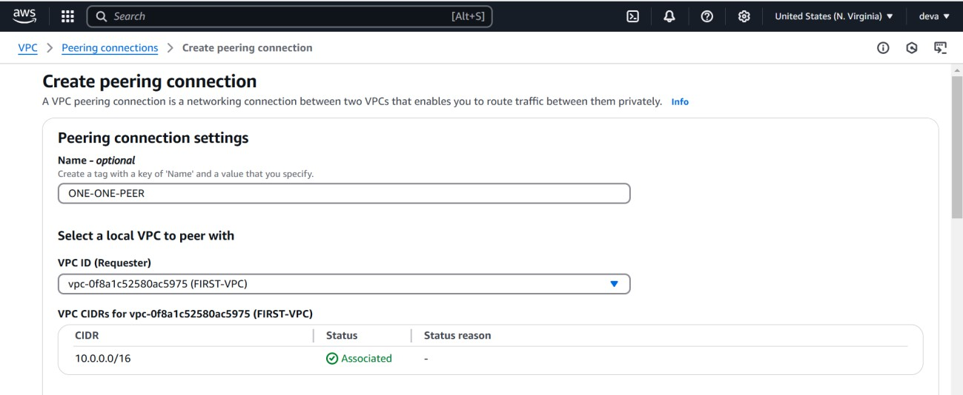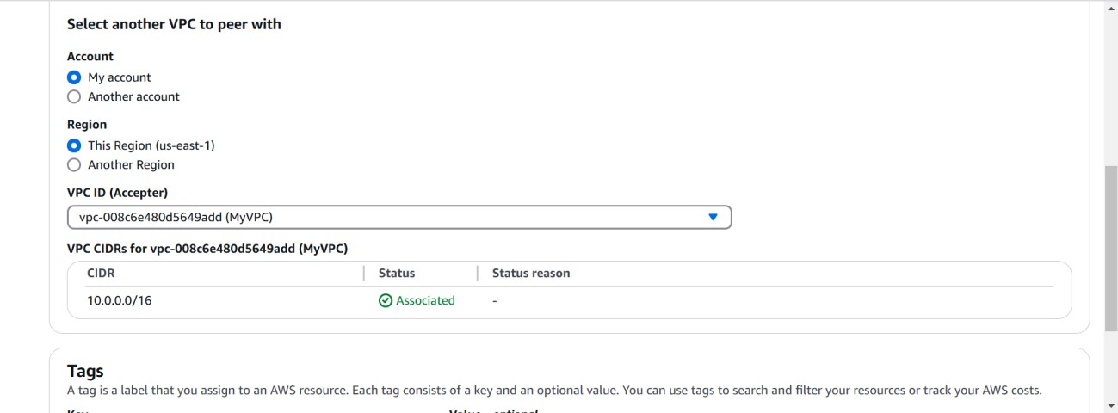

Click on the creat peering button that is visible on the bottom right downside to create

peering connection for the two VPC’S and after that we need to go to another vpc in the another region and we need to accept the peering request on the vpc b also after accepting the request we need to modify the route tables to set up the peering connection successful.

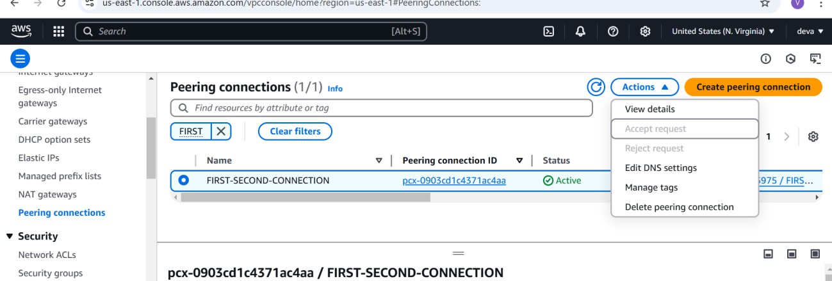

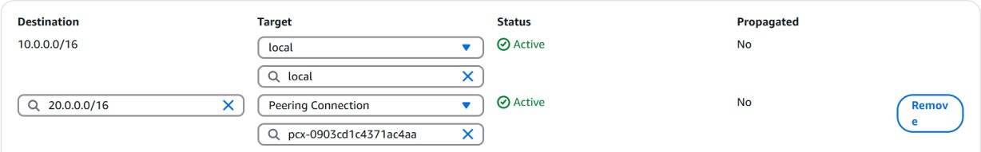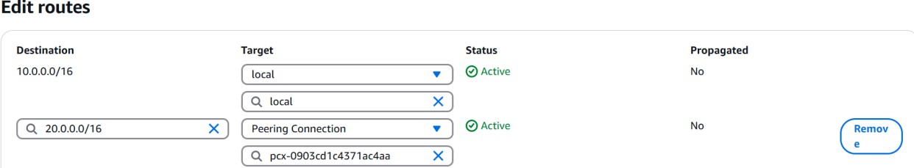

And hence the modification of route tables has been done so , our vpc peering connection set up has been completed successfully.

We need to set up the RDS database in the VPC B so that the user requests the temperature for any city from the frontend the backend needs to store that city and temperature of that city in the RDS database.

## Steps to Create an RDS Database:

1. **Open AWS Console** → Navigate to **RDS Dashboard** → Click **Create Database**.
2. **Select Database Engine** (MySQL, PostgreSQL, etc.) and **Version**.
3. **Set Database Identifier**, Master Username, and Password.
4. **Choose Instance Type** (e.g., db.t3.micro for Free Tier) and **Storage Size**.
5. **Configure VPC, Subnet Group, and Security Group** for connectivity.
6. **Enable or Disable Public Access** based on security needs.
7. **Set Backup Retention**, Monitoring, and Logs (optional).
8. **Click "Create Database"** and wait for the instance to be available.
9. **Get the RDS Endpoint** from the AWS Console.
10. **Connect using MySQL Client** via EC2 or local system:

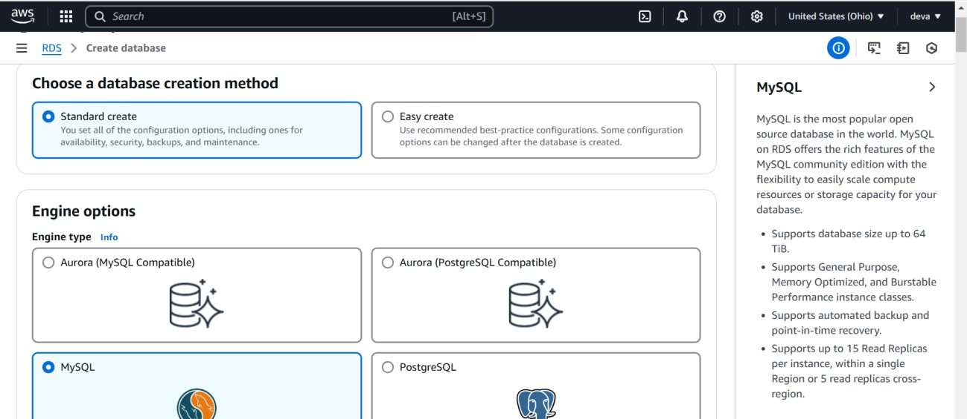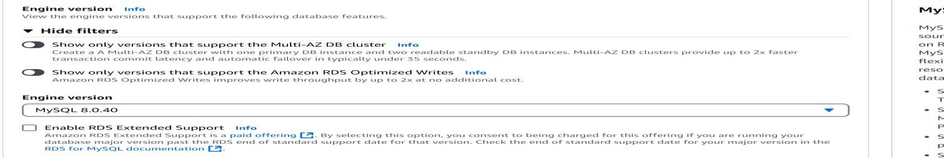

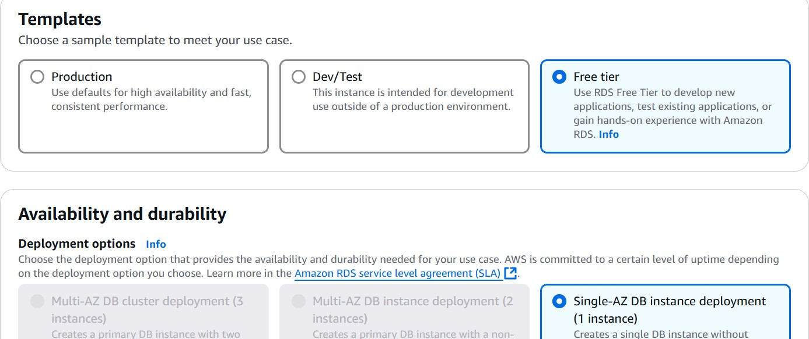

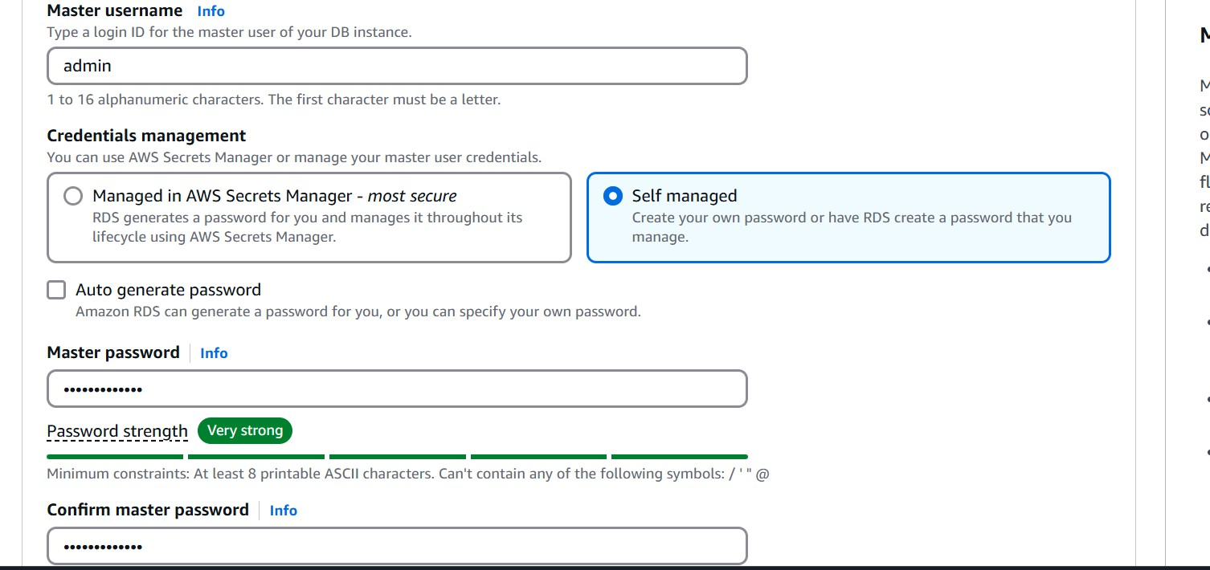

Select the master username and master password for the database that you create because that username and password will be helpful while giving connection to your database , we need to give that credentials.

Choose the vpc that you have created and within that vpc try to create the database so that we can give the connection try to make sure that carefully.

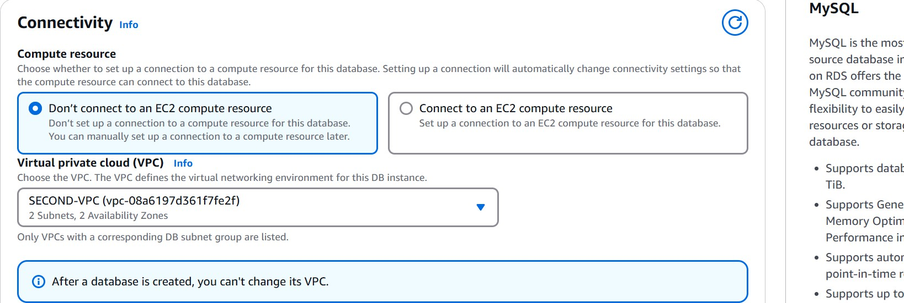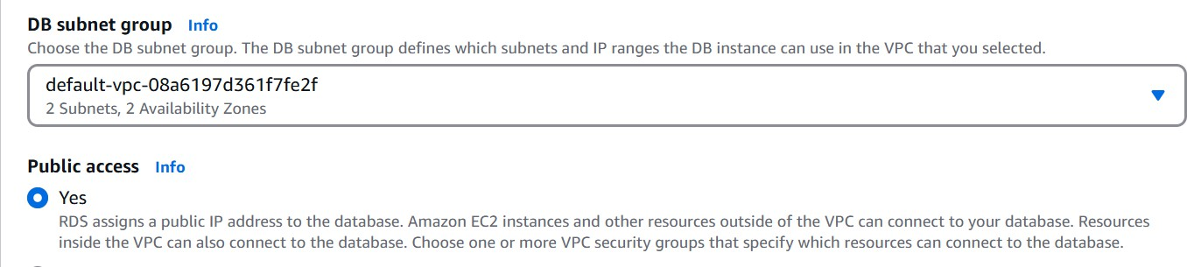

Make sure the subnet is default and it is publicly accessible for use otherwise.in additional configuration try to give the initial database name as you want and try to leave all the things asusal.

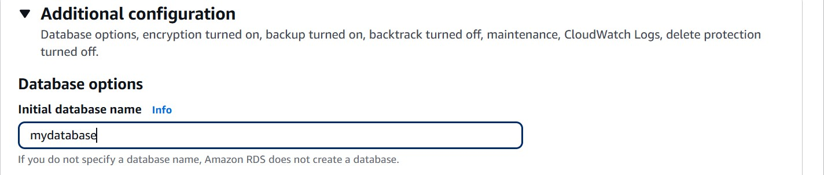

Click on create database then the database on your region will be created so that you can store the data in that database and can access the data for your use.

## Steps to Create a Private Instance in VPC B Using the Security Group of VPC A’s Private Subnet:

### Step 1: Open AWS EC2 Dashboard

1. Sign in to the **AWS Console**.
2. Navigate to **EC2 Dashboard** → Click **Launch Instance**.

### Step 2: Choose an AMI

1. Select an **Amazon Machine Image (AMI)** like **Amazon Linux 2** or **Ubuntu**.

### Step 3: Choose Instance Type

1. Select an instance type (e.g., **t2.micro** for Free Tier).

### Step 4: Configure Instance in VPC B

1. Select **VPC B** under **Network Settings**.
2. Choose the **Private Subnet of VPC B** (e.g., 20.0.200.0/24).
3. **Disable Auto-assign Public IP** since it's a private instance.

### Step 5: Assign Security Group from VPC A

1. Under **Security Groups**, select **Existing Security Group**.
2. Choose the **Private Subnet Security Group from VPC A**.
3. Ensure it allows inbound traffic from **VPC A’s CIDR** (e.g., 20.0.100.0/24).

### Step 6: Add Storage and Tags

1. Configure **storage** (e.g., 8GB default for Free Tier).
2. Add **tags** (optional) for easier identification.

### Step 7: Launch the Instance

1. Click **Review and Launch** → Select or create a **key pair**.
2. Click **Launch Instance** and wait for it to start.

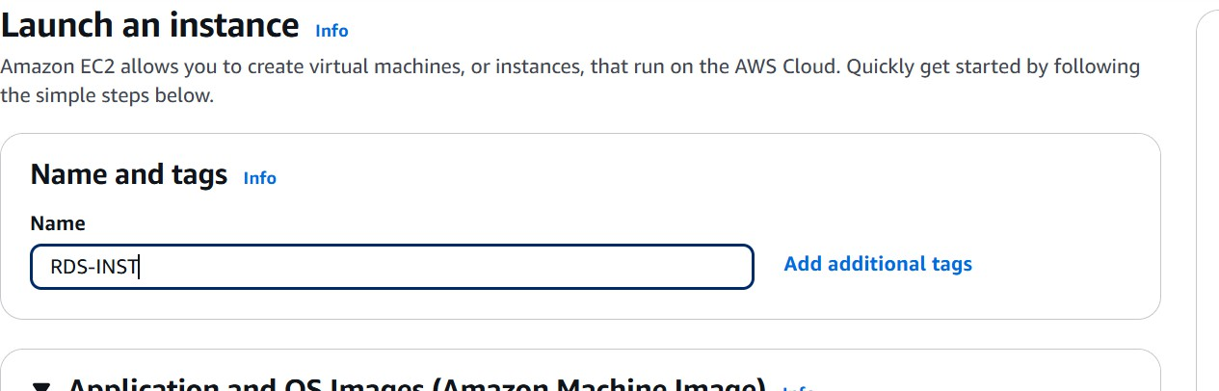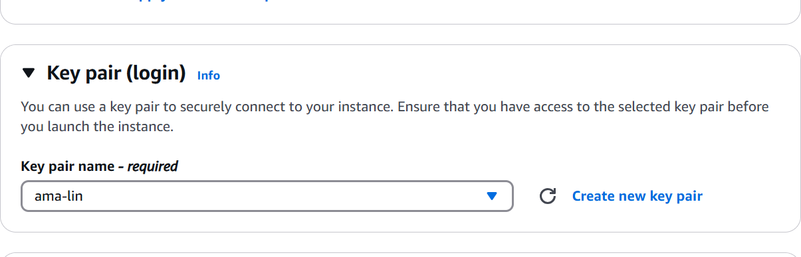

Choosing the security group is the important one when it comes to this instance because we need to allow the data in to this instance form the users who comes to the private instance in the VPC A .

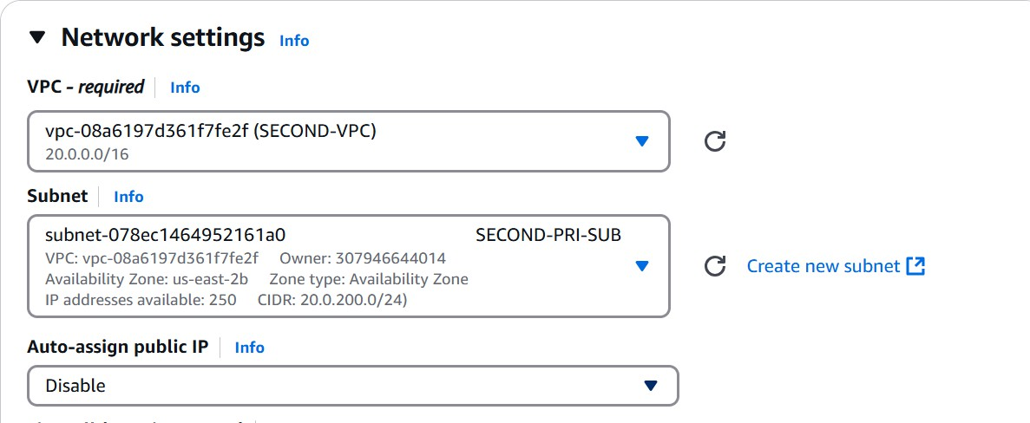

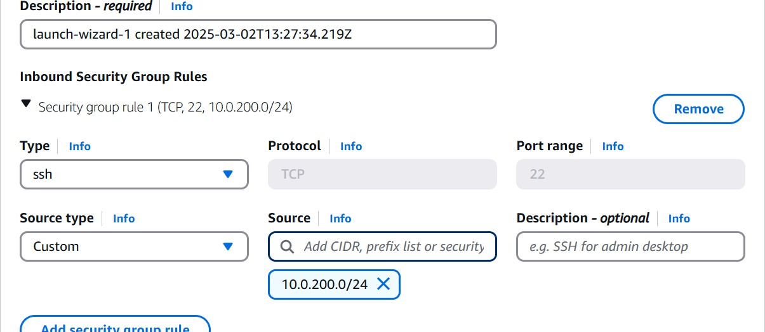

This is the security group of the private subnet in vpc A.

Then click on the launch instance that will create an instance in the private subnet of vpc B and in that we need to configure the database , we need to create table in that and we need to store the data in that table.

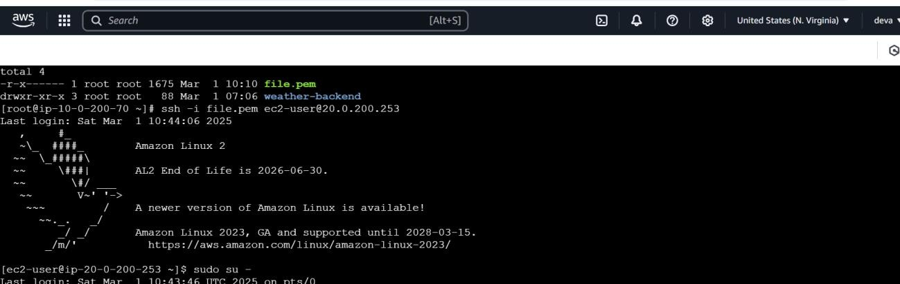

Through private instance of vpc A i came in to private instance of vpc B and i have created a database called capstone where i store all the data in the database within weather_data table.

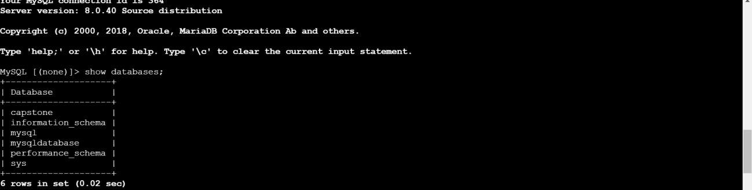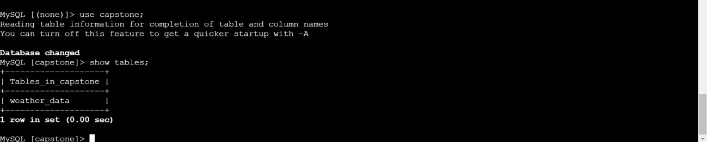

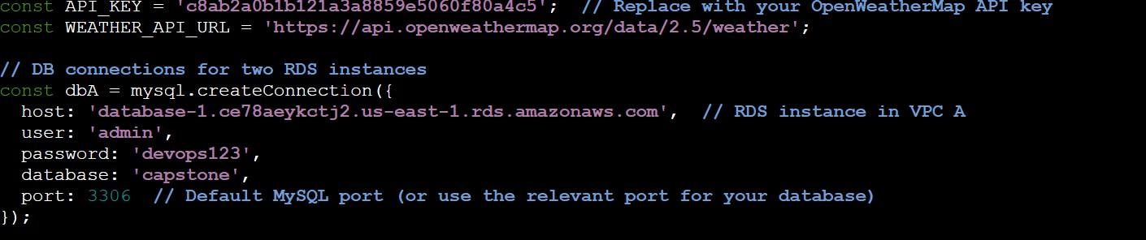After creating the database for storing the data and table within that database we need to give database connection to the backend from where we get the data to send to the database. So configure the backend with the database.

We need to have this code in the backend server.js file to connect this to the database and to store the data in the database we need to add another code to connect to the database.

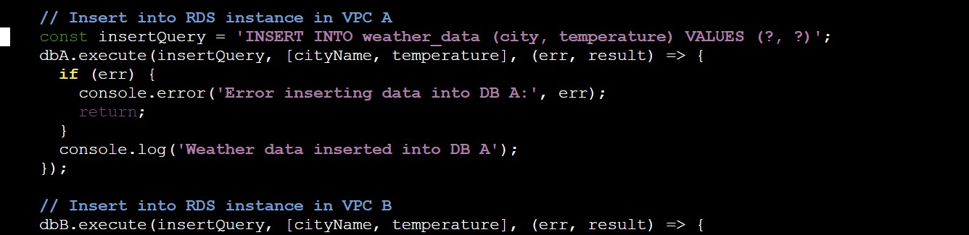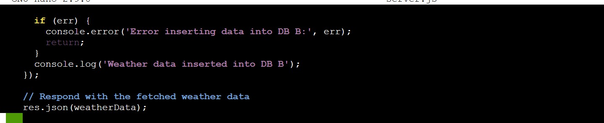

After this we can see the output will go in to the database when the user makes the request form the front end.

## Screen shots of that will be,

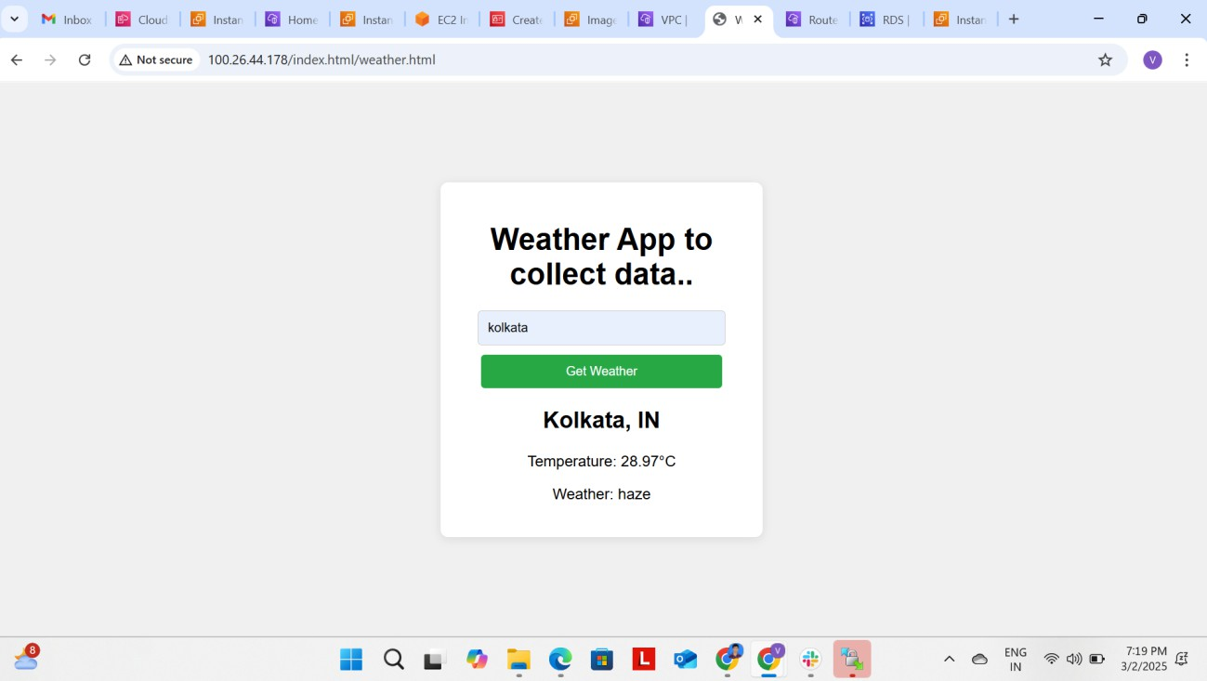

When we enter the city name it will show the temperature of that city and that city name and the temperature will go and store in the RDS database. The database screenshots are going to be like;

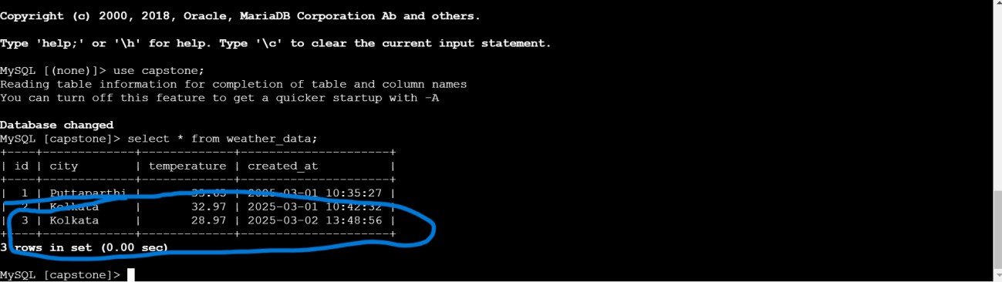

Here we can see the data is being stored in the database at last row like wise we can store the city and temperature of that city and time at which it is stored all these things we can see the in the database when user enter the location or city.

## creating code deploy and code pipeline for the updation of environment:

* 1. We need to create an S3 bucket for pushing the code in to the s3 bucket.
  2. We need to create an application the code deploy.
  3. After that create a deployment group in the code deploy and create deployment by showing the destination as EC2 production server.
  4. The source should be taken as the s3 bucket.

Form the ec2 instance where you have your fornt end files push them in to the s3 bucket created.

## Steps to Create an S3 Bucket in AWS:

1. **Open AWS Console** → Navigate to the **S3 Dashboard**.
2. Click **Create Bucket**.
3. **Enter Bucket Name** (must be globally unique).
4. **Select AWS Region** where you want to create the bucket.
5. **Disable or Enable Public Access** based on security needs.
6. **Enable Versioning** (optional for backup and recovery).
7. **Set Default Encryption** (optional for security).
8. Click **Create Bucket**.

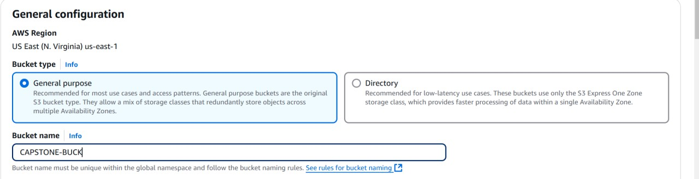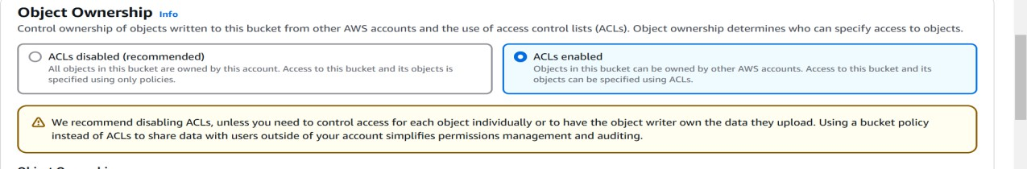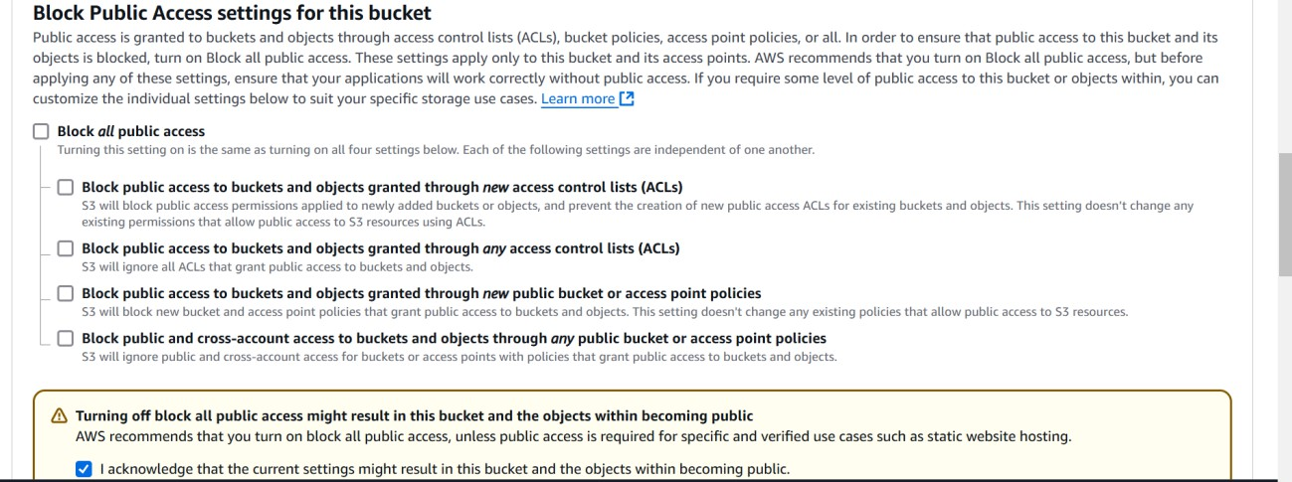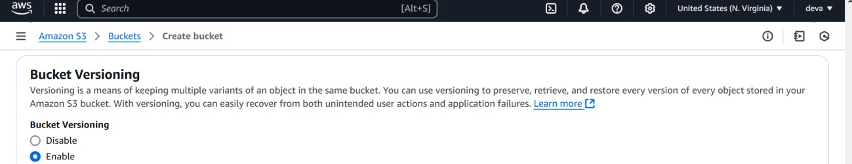

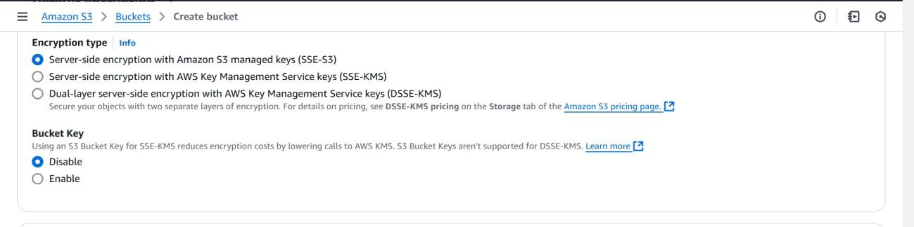Here we need to enable the bucket versioning so that we can update the new versions through code deploy for the application that you create.

Click on the create bucket button then you will get a bucket in this bucket you store all the zip file versions of your code .

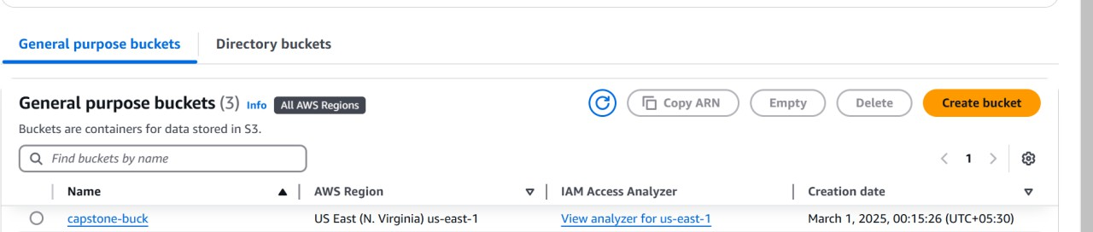

Go to the aws machine and push the code in to the s3 bucket so that we can choose the source as the s3 for code deploy and destination as the ec2 production server.

Command to push the code in to s3 :

## Aws s3 push –application-name weather-app.zip s3://capstone-buck

This will push the source code in to the s3 bucket and from here we can deploy the code in the code deployment.

## Creating deployment group in the code deploy:

* **Open AWS Console** → Navigate to **CodeDeploy**.
* Click **Create Application** and enter an **Application Name**.
* Choose **Compute Platform** (e.g., **EC2/On-Premises**).
* Click **Create Deployment Group**.
* Enter a **Deployment Group Name**.
* Select the **Service Role** (IAM role with CodeDeploy permissions).
* Choose the **Deployment Type** (In-Place or Blue/Green).
* Select **EC2 Instances or Auto Scaling Groups** to deploy the application.
* Choose the **Deployment Configuration** (e.g., **CodeDeployDefault.AllAtOnce**).
* (Optional) Enable **Load Balancer** for traffic shifting.
* Click **Create Deployment Group**.

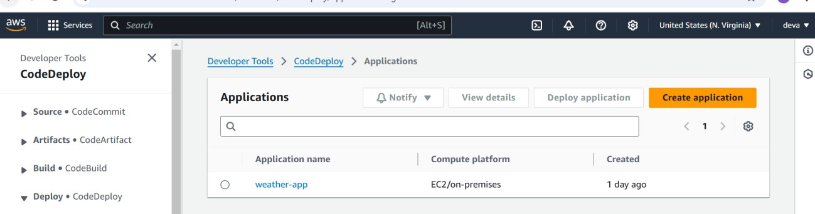

Click on that application and inside that create deployment group choose the source as the s3 and destination as ec2 production server.

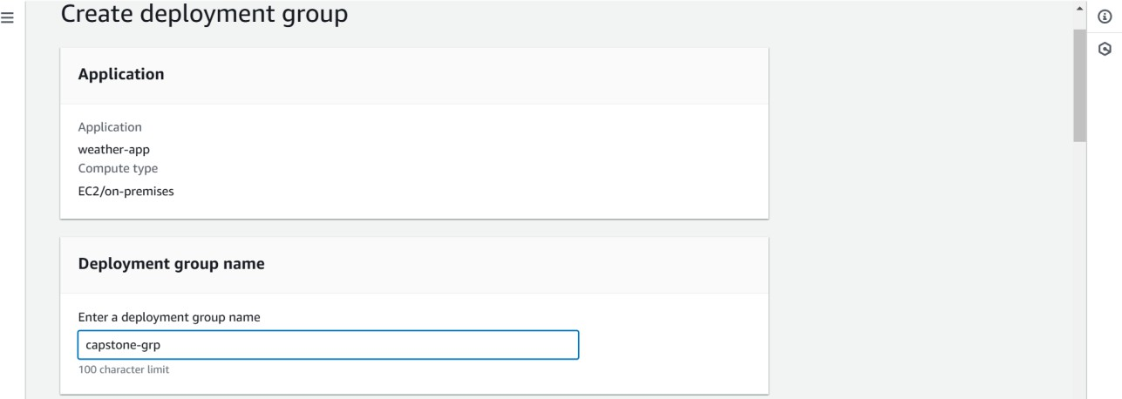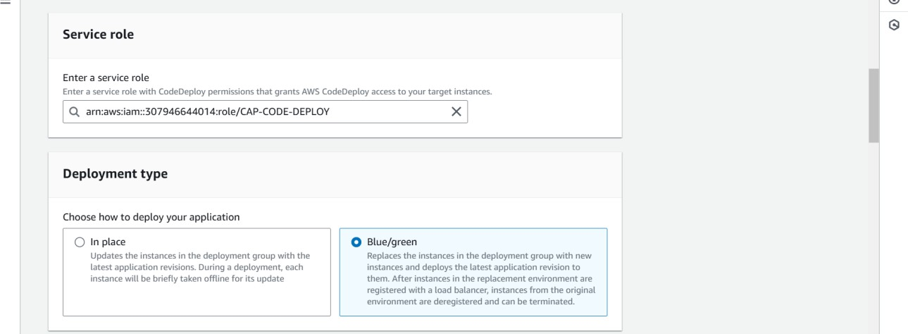

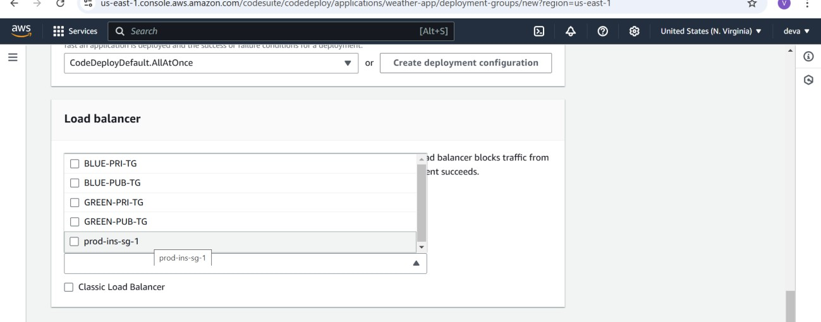

Select the target where you want to route the traffic with the loadbalancer and we need to show the instance for the traffic.

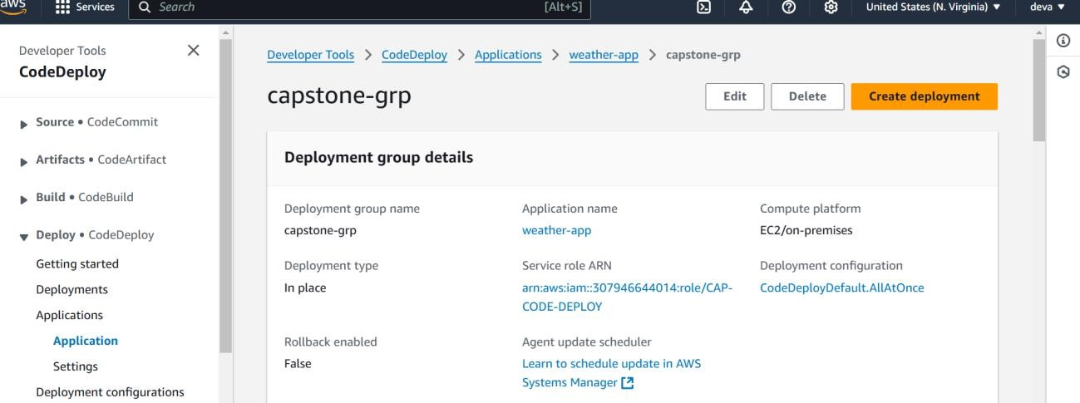

Once the deloyment group has been created then click on the create deployment so that it will create depoyment for us and we can see that status success.

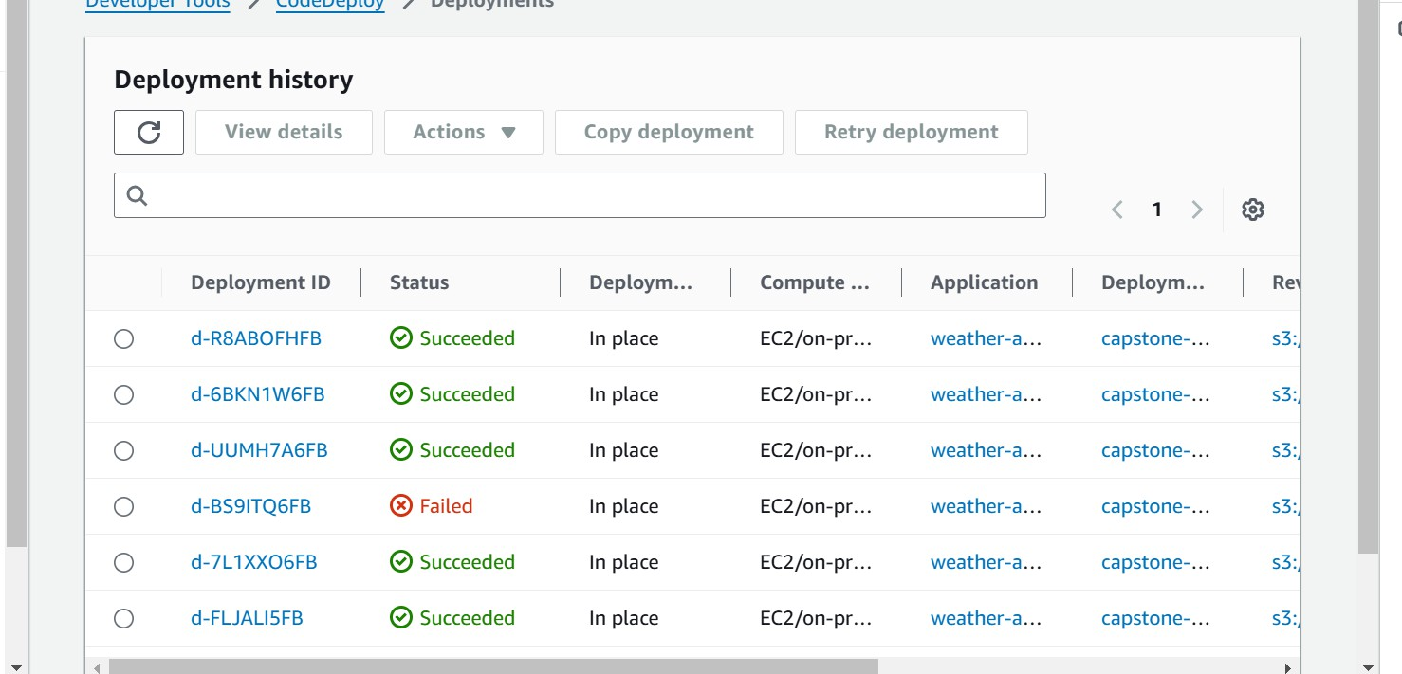

We can see the output in the browser after the deployment by just pasting the public ip address of the production server.

# creating blue – green deployment using code deploy:

I have created four instances two for the blue environement and two for the green environment in green instances we are going to do the development process and whatever the updates we want to show for the application and in the blue environment we will show the application for the user and we will route the traffic to the blue environment with the application load balancer.

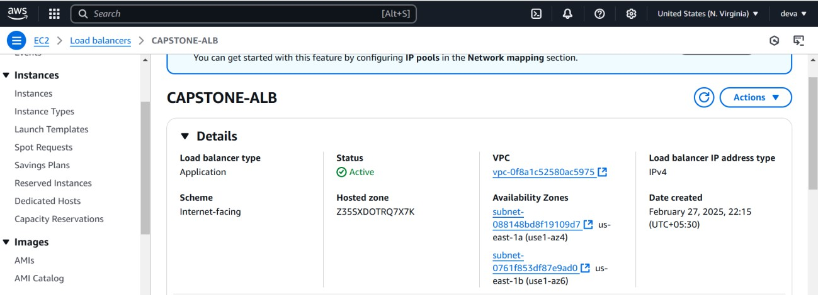

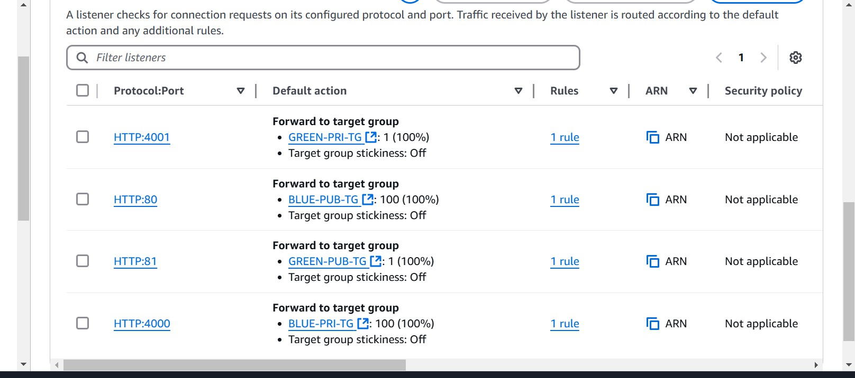

I have added these four listeneres for the application load balancer and i have created four target groups two for the **public blue and green** and two for the **private blue and green.**

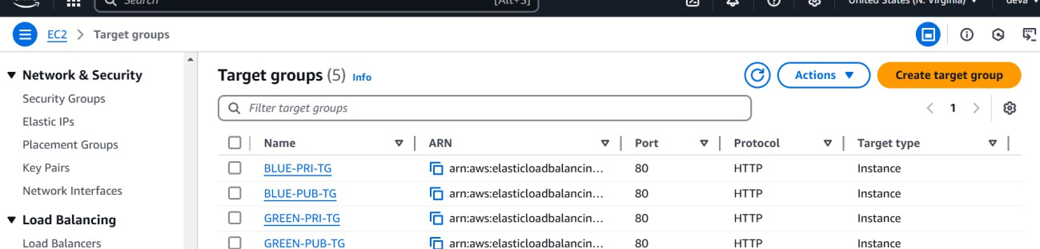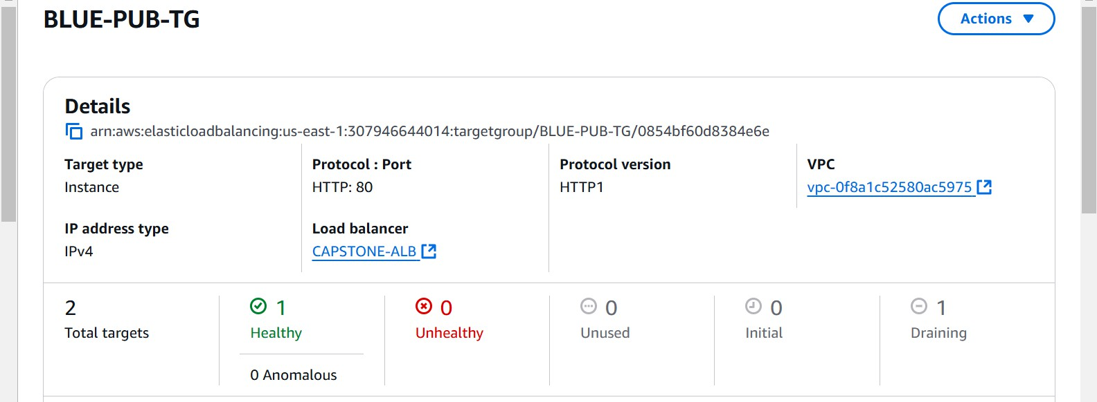

I have also created health check for the Blue production server it is showing healthy so we can route traffic to the blue instance where users can get to see the output in the browser.

## Creating Codepipeline for codedeploy :

* **Open AWS Console** → Navigate to **CodePipeline**.
* Click **Create Pipeline** and enter a **Pipeline Name**.
* **Select Service Role** (Create a new role or use an existing one).
* Click **Next** and choose **Source Stage** (e.g., S3, GitHub, CodeCommit).
* Configure the **Source Provider** (e.g., specify S3 bucket or GitHub repo).
* Click **Next** and select **Build Stage** (optional, e.g., CodeBuild for testing).
* Click **Next** and choose **Deploy Stage** → Select **AWS CodeDeploy**.
* Select the **CodeDeploy Application** and **Deployment Group**.
* Click **Next**, review configurations, and click **Create Pipeline**.

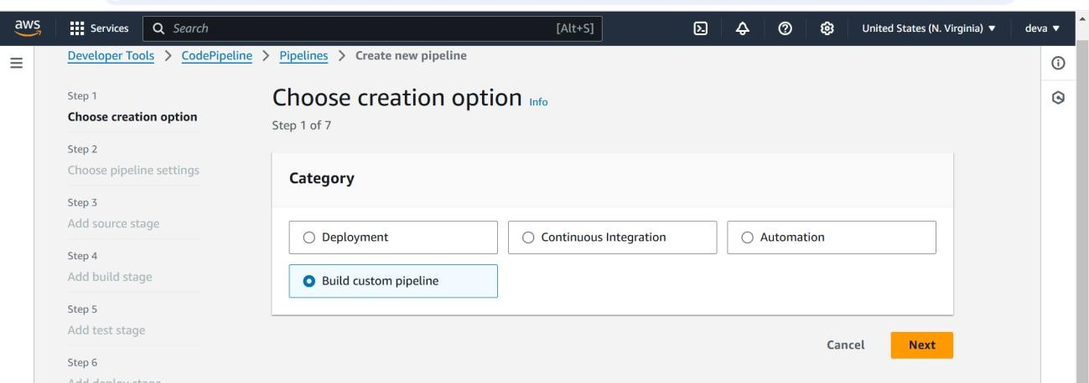

Click next to go to another step to proceed to further stages and in the pipeline setting s we need to make some changes for that.

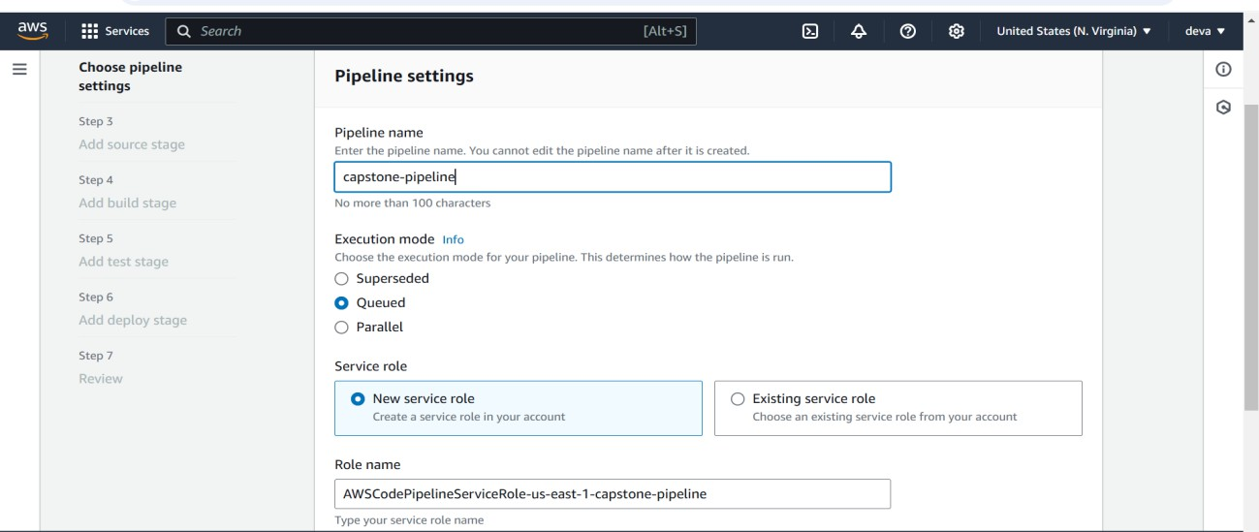

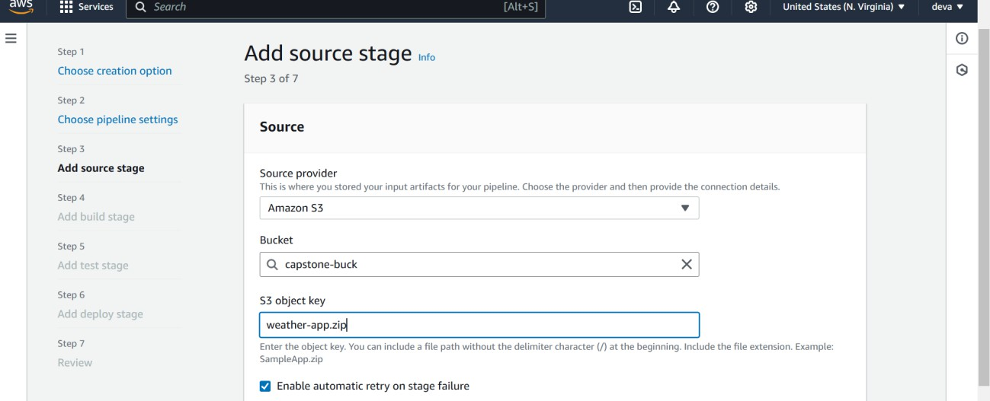

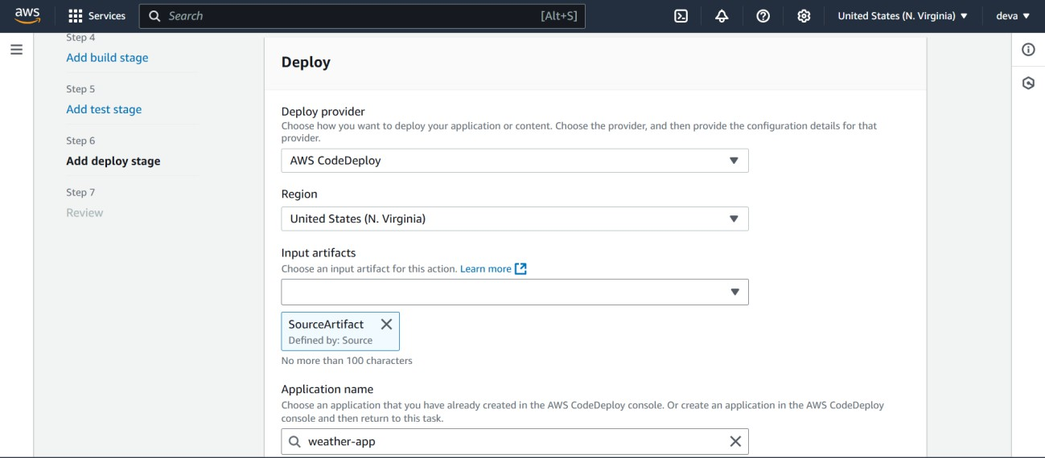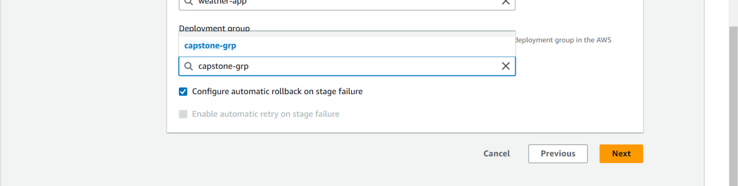

These are the steps that we need to make for the codepipeline to create the pipeline for our weather-app and after all these steps we are ready with our codepipeline if any advancements taken place in our code code pipeline will trigger and updates codedeploy.

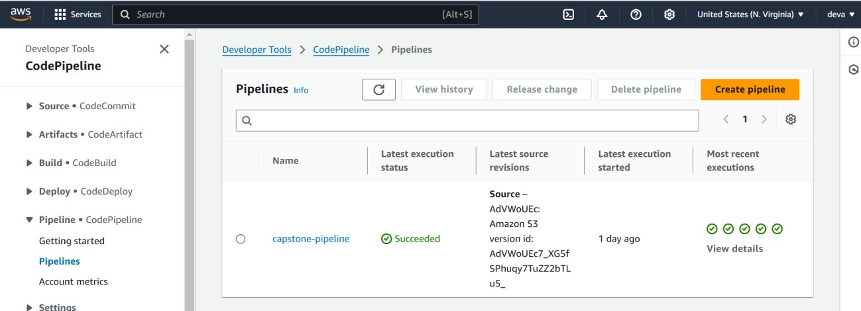

## Testing the code pipeline with some customizations in your code :

Testing the code with all the updates and changes you made for the source code and after doing all these things you need to push the source code in to the s3 bucket and from the s3 bucket the code pipeline will trigger and deploy the changes to the application in the production server , we can see the chagnes in the ouput.

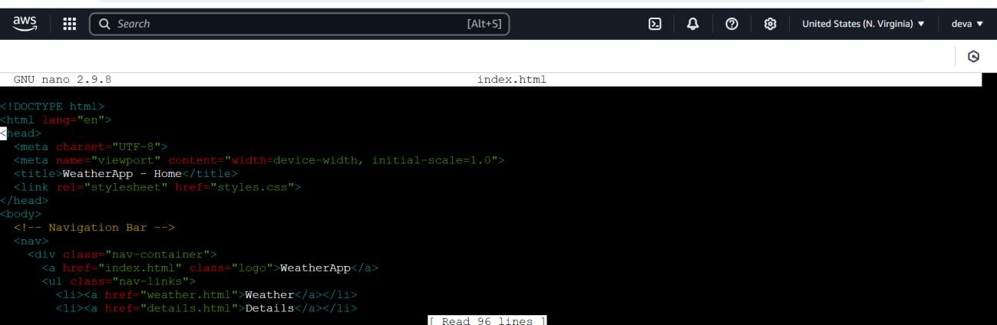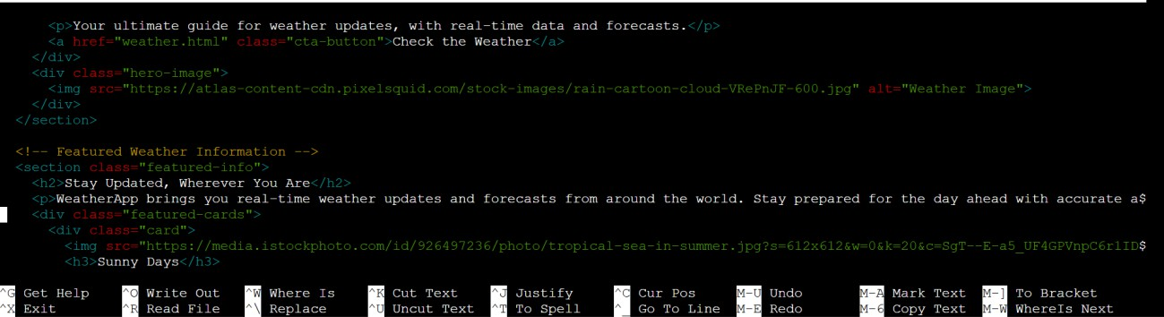

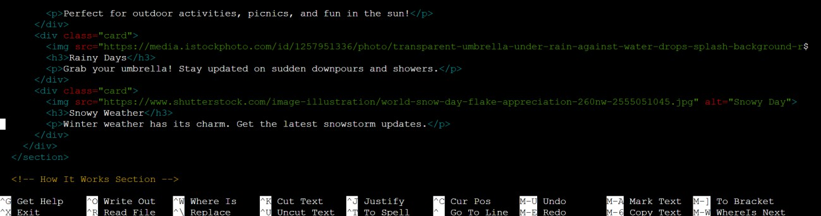

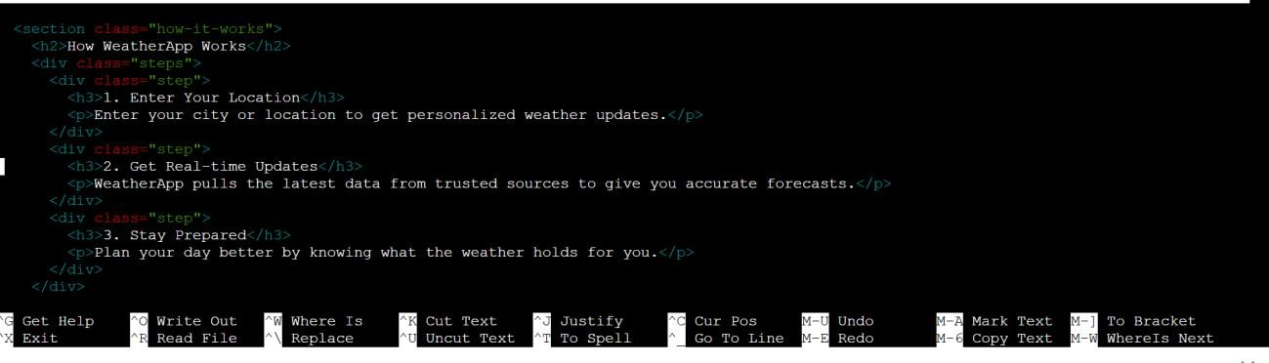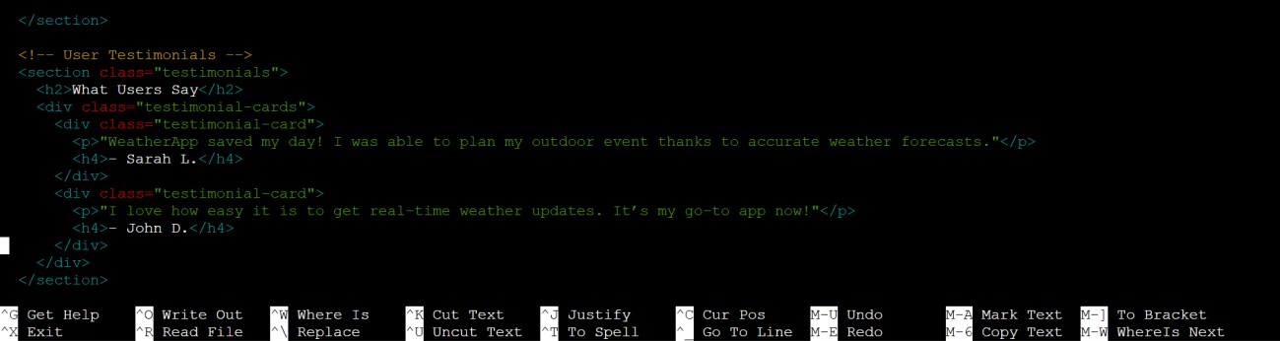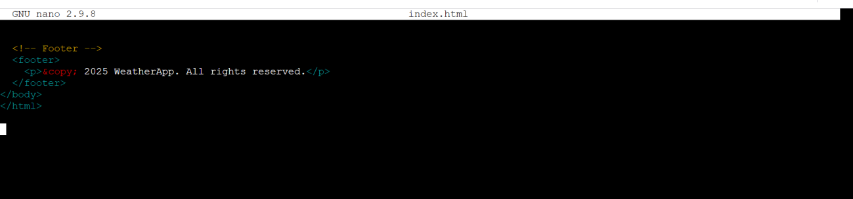

These are the modifications that i have done in my forntend application and in backend i have kept the same without doing any modifications and i have also done some modifications in my database section as well.

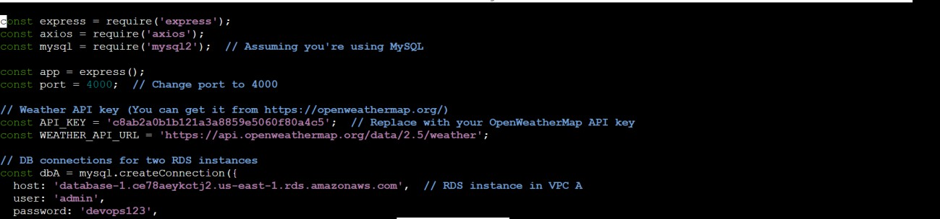

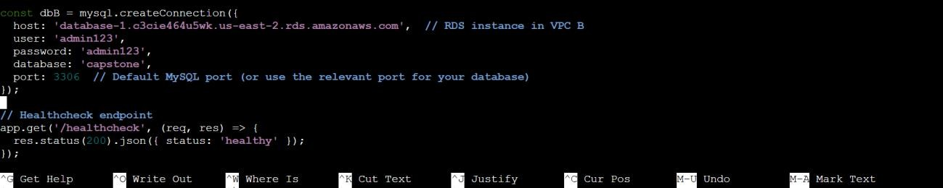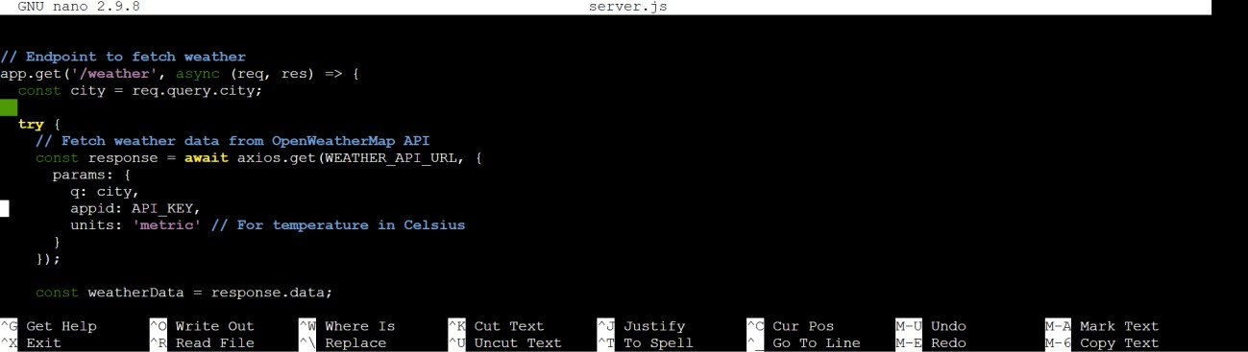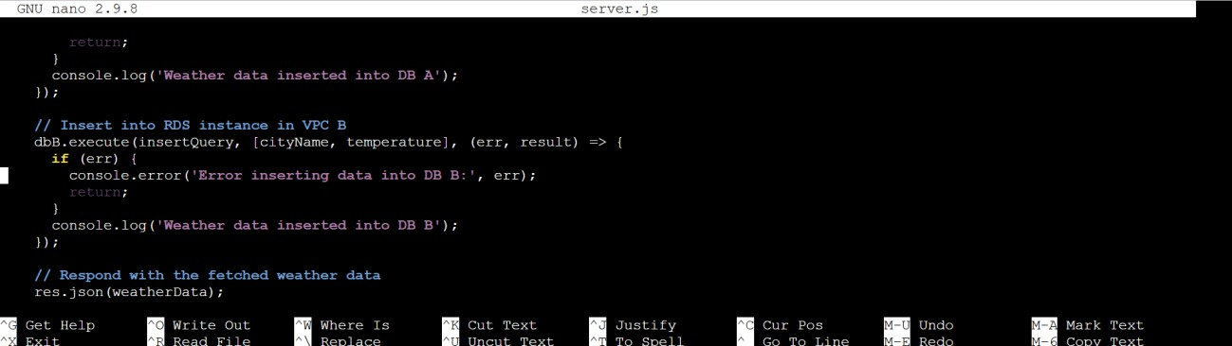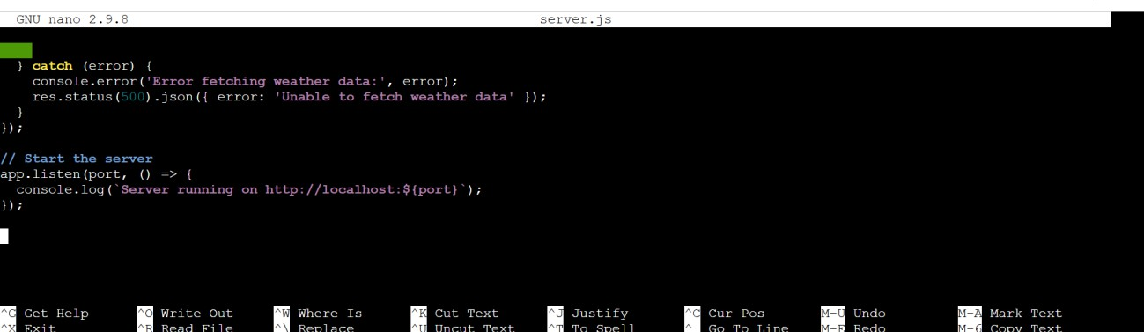

After doing all the customizations we need to push again the code again in to the s3 the commands we need to use for this again are;

Commands :

## Zip -r weather-app.zip weather-app

**Aws s3 cp weather-app.zip s3://capstone-buck**

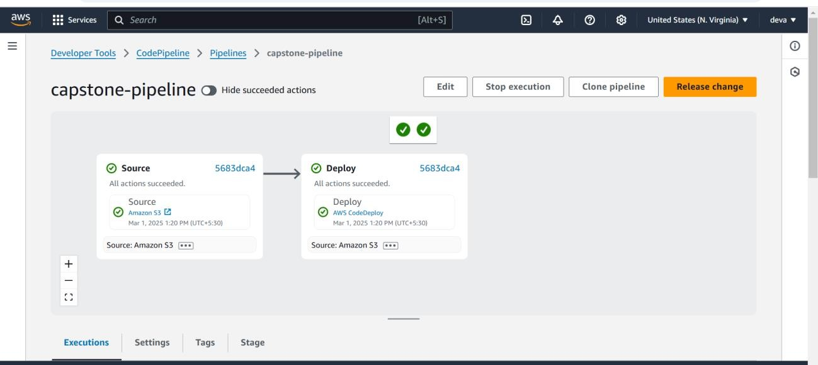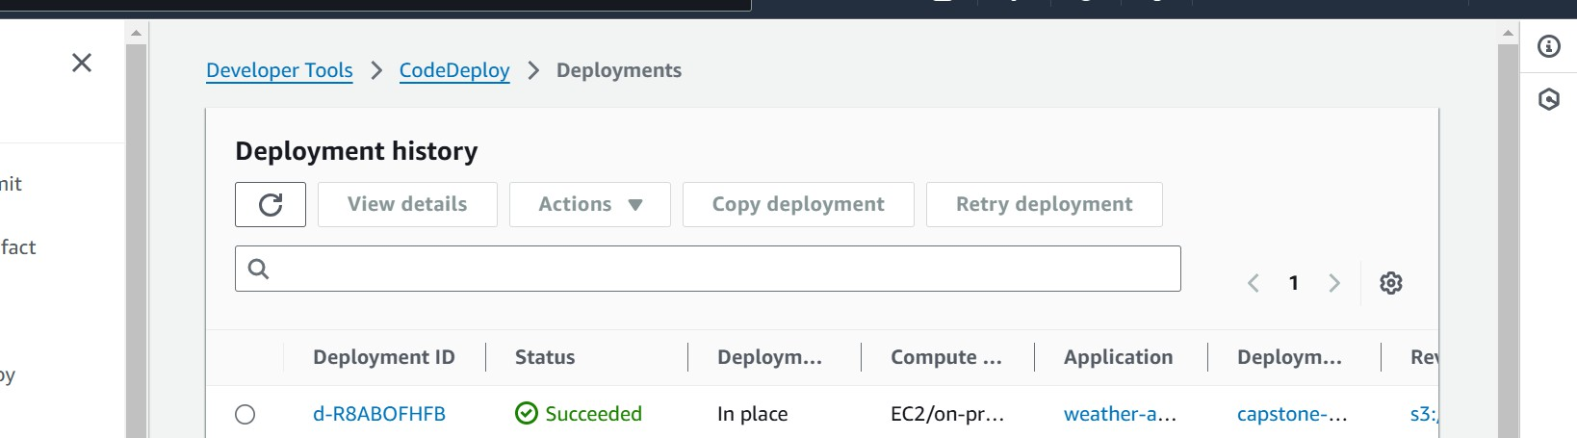

After triggering the pipeline all the changes have been deployed to the application through the code deploy and we can see the ouputs in the browser.

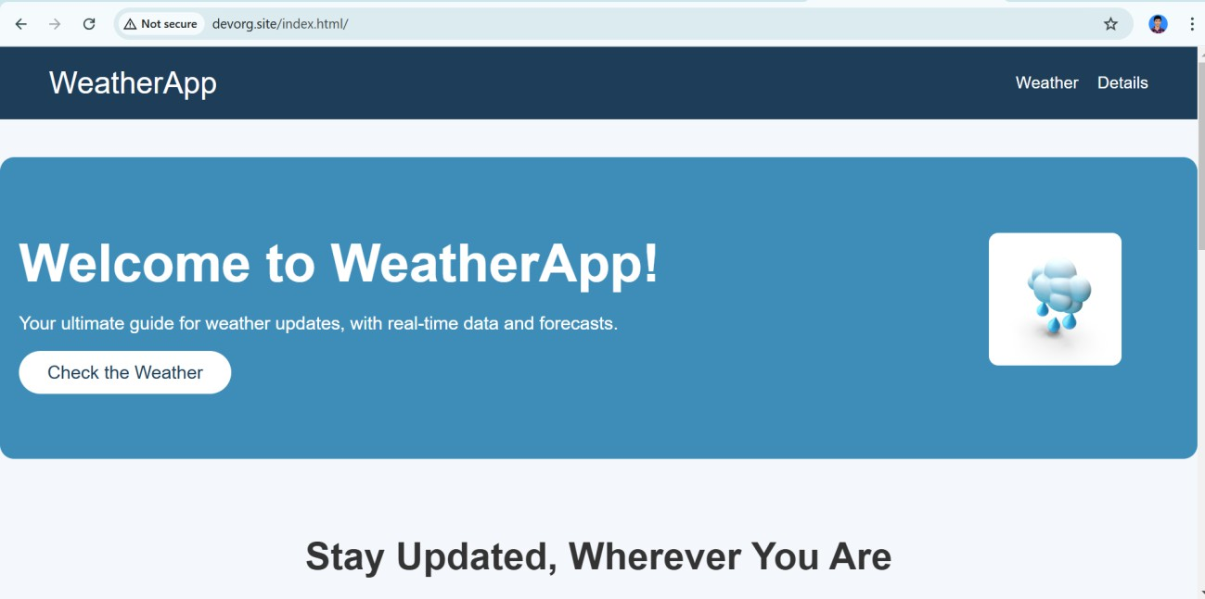

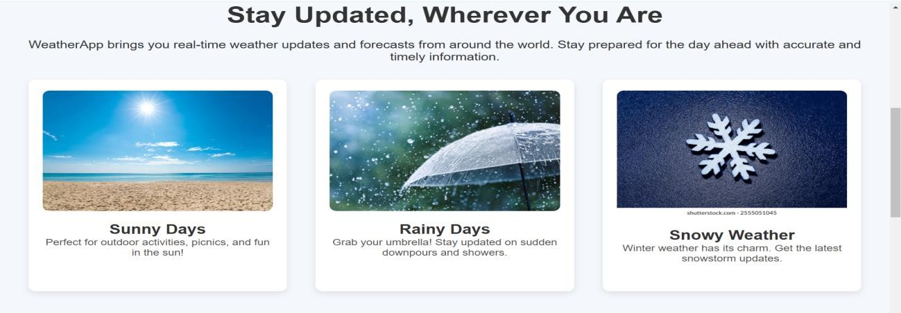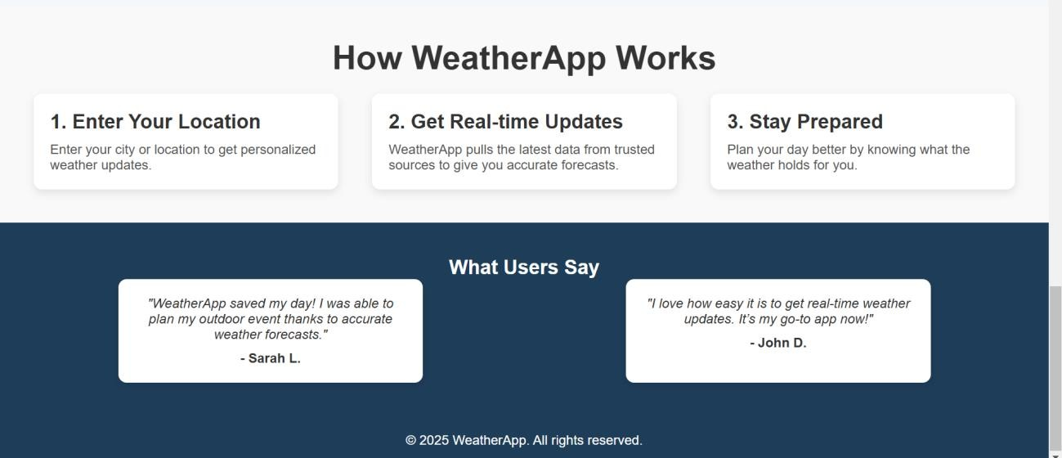

By clicking on the weather button or check weather that navigates you to the weather page where you can see the weather by entering the city name and that city name you enter and the weather of that city and time stamp of the temparature will be stored in the rds datbase which is there in the private instance of VPC B.

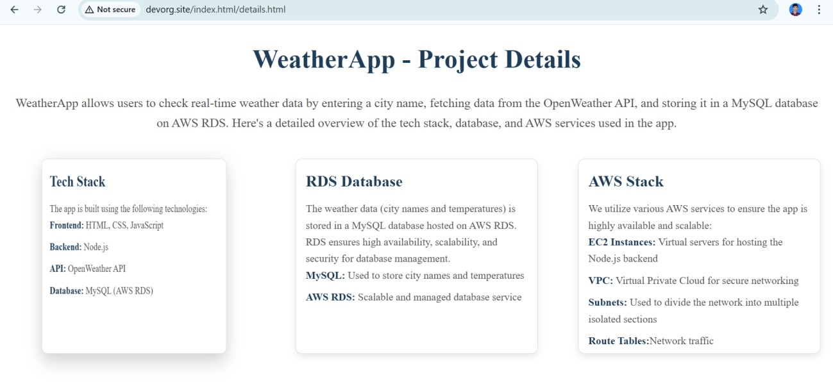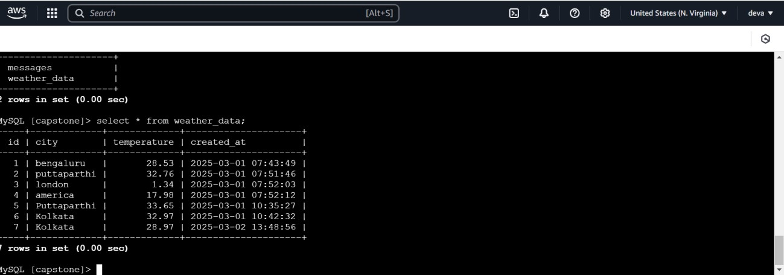

This is the output that we got in the application in the browser and the same output is stored in the database as well.

## Attaching auto scaling group to the code deploy :

* **Open AWS Console** → Navigate to **EC2 Dashboard** → Click **Auto Scaling Groups**.
* Click **Create Auto Scaling Group**.
* Enter an **Auto Scaling Group Name**.

## Select an Existing Launch Template or Create a New Launch Configuration.

* Choose a **VPC** and select **Subnets** for instance distribution.

## Set Desired, Minimum, and Maximum Instance Counts.

* Configure **Scaling Policies** (Target Tracking, Step Scaling, or Scheduled Scaling).
* Attach an **Application Load Balancer (ALB)** (Optional).
* Enable **Instance Health Checks** and Recovery Actions.
* Click **Create Auto Scaling Group**.

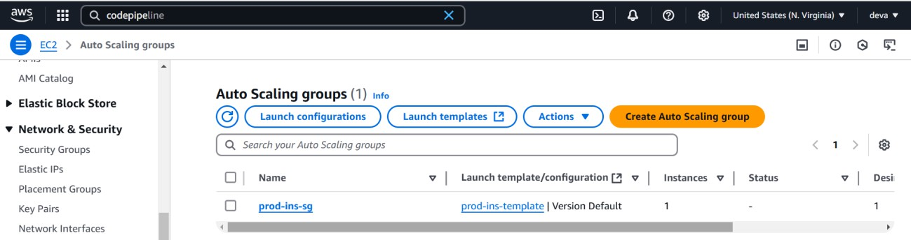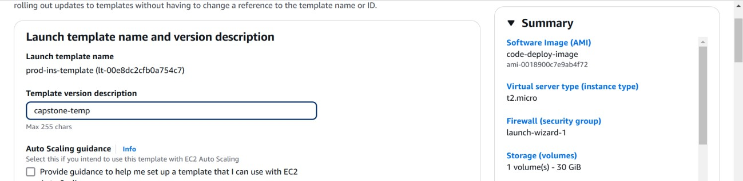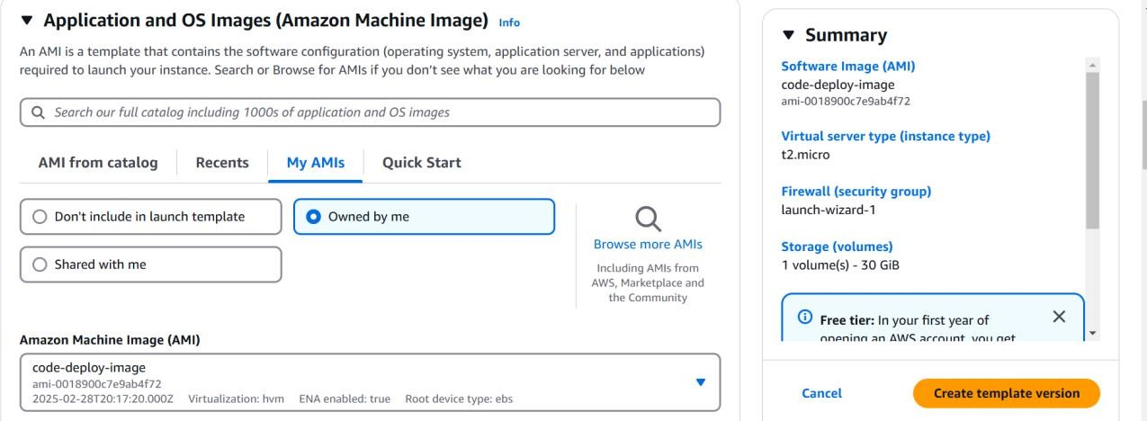

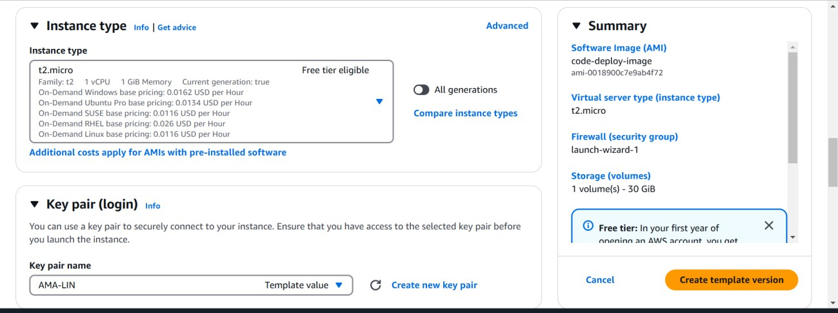

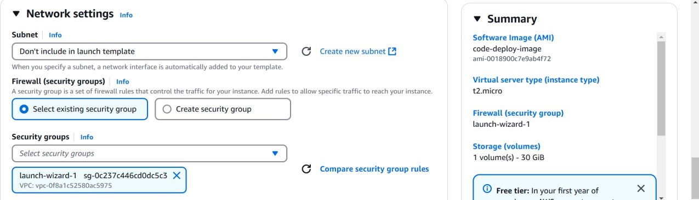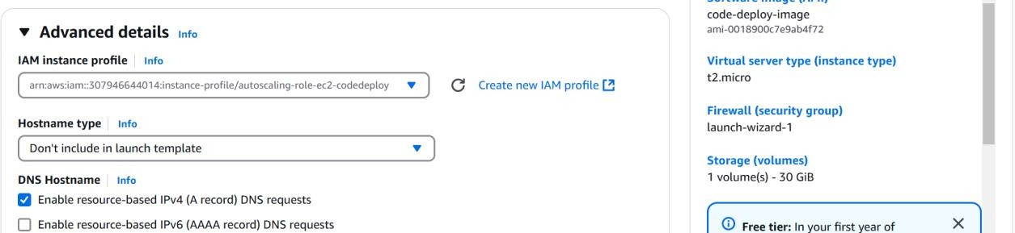

This is the template for the auto scaling for the ec2 instances and whenever the instance is unhealthy the auto scaling group creates a healthy instance for the production server that is the main purpose of the auto scaling.

We need to configure the enviroment for the code deploy with this auto scaling group then when ever code deploy happens then the auto scaling creates a new instance for us.

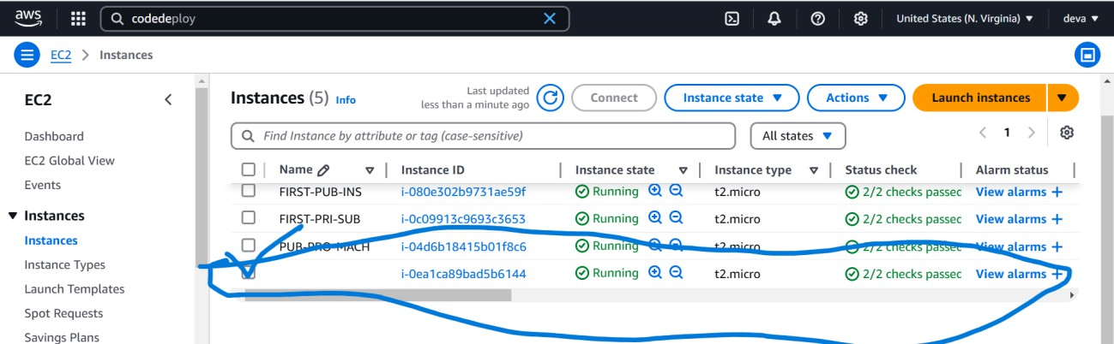

Rounded up instance is the new instance created by the auto scaling group for the deployment server.

## Creating SNS topic and notification to mail and SQS for code deploy :

### Step 1: Open SNS Console

1. Sign in to the **AWS Console**.
2. Navigate to **Amazon SNS** → Click **Create Topic**.

### Step 2: Create a New Topic

1. Select **Standard** as the topic type.
2. Enter a **Topic Name** (e.g., CodeDeploy-Notifications).
3. Click **Create Topic**.

### Step 3: Create Subscriptions (Email & SQS)

**For Email Notification:**

1. Open the created topic → Click **Create Subscription**.
2. Choose **Protocol: Email**.
3. Enter the **Email Address** → Click **Create Subscription**.
4. Check your email and **confirm the subscription**.

**For SQS Notification:**

1. Open the SNS topic → Click **Create Subscription**.
2. Choose **Protocol: Amazon SQS**.
3. Select the **SQS Queue** you want to subscribe to.
4. Click **Create Subscription**.

### Step 4: Integrate SNS with CodeDeploy

1. Open **AWS CodeDeploy** → Click **Applications**.
2. Select your application → Click **Deployment Group**.
3. Scroll to **SNS Notifications** → Select the SNS topic.
4. Click **Update Deployment Group**.

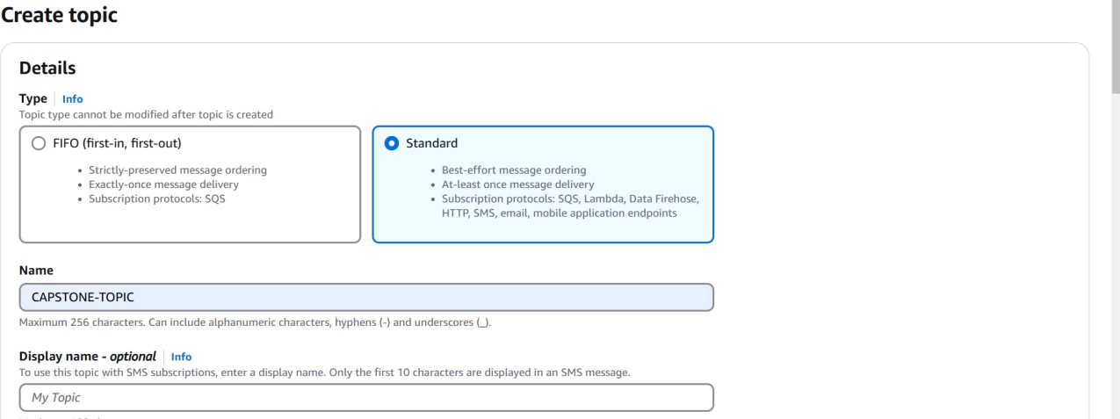

{

"Version": "2008-10-17",

"Id": " default_policy_ID", "Statement": [

{

"Sid": " default_statement_ID", "Effect": "Allow",

"Principal": {

"AWS": "*"

},

"Action": [ "SNS:GetTopicAttributes", "SNS:SetTopicAttributes", "SNS:AddPermission", "SNS:RemovePermission", "SNS:DeleteTopic", "SNS:Subscribe", "SNS:ListSubscriptionsByTopic", "SNS:Publish"

],

"Resource": "arn:aws:sns:us-east-1:123456789012:capstone-topic", "Condition": {

"StringEquals": {

"AWS:SourceOwner": "123456789012"

}

}

},

{

"Sid": "AWSCodeStarNotifications_publish", "Effect": "Allow",

"Principal": {

"Service": [

"[codestar-notifications.amazonaws.com](http://codestar-notifications.amazonaws.com/)"

]

},

"Action": "SNS:Publish",

"Resource": "arn:aws:sns:us-east-1:123456789012:capstone-topic"

}

]

}

Click on the create topic of sns for the code deploy and create two subscriptions for the sns topic one is sqs and another one is email.

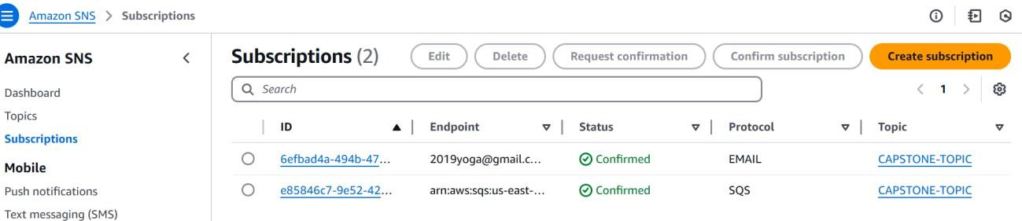

Create noficiation rule in the code deploy for getting the sns notification for the mail and the sqs about the message that we get when trigger the code deploy using the code pipeline.

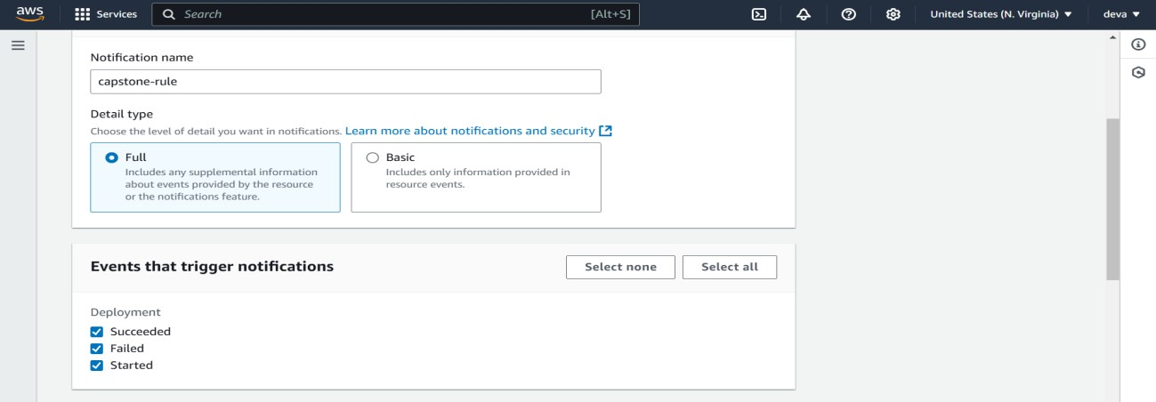

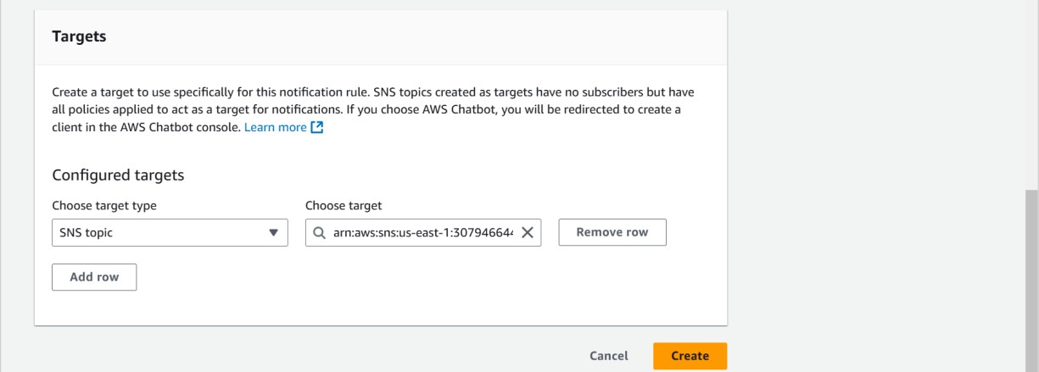

Then create the notification rule for sns in code deploy to get the message for the output.

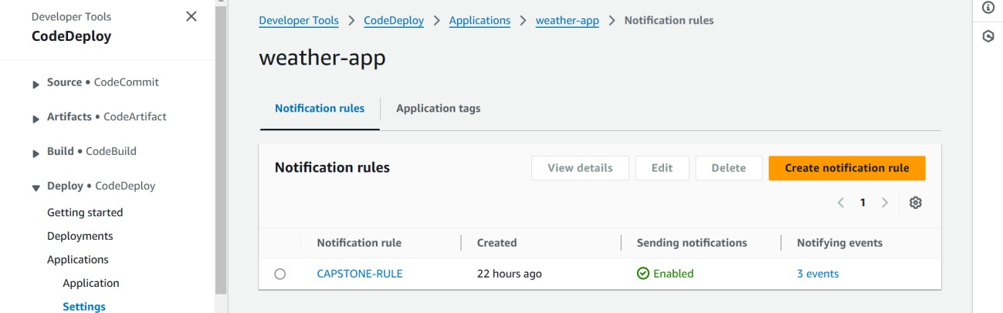

After enabling the rule and connecting with the sns topic the output is going to be the ;

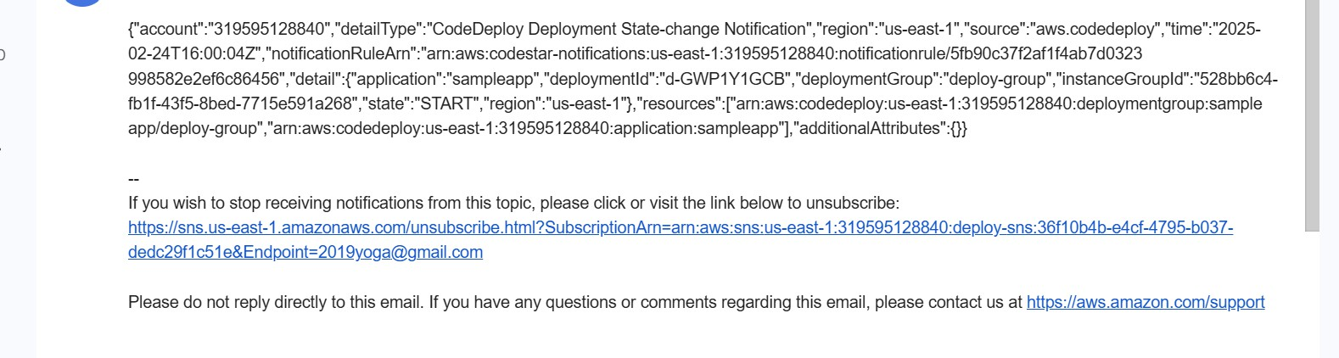

## Connecting route 53 with the prod isntance ip address:

### Step 1: Open Route 53 Console

1. Sign in to **AWS Console**.
2. Navigate to **Route 53** → Click **Hosted Zones**.

### Step 2: Create a New Hosted Zone

1. Click **Create Hosted Zone**.
2. Enter your **Domain Name** (e.g., devorg.site).
3. Select **Public Hosted Zone** for internet access or **Private Hosted Zone** for internal networking.
4. Click **Create Hosted Zone**.

### Step 3: Add DNS Records

1. Click on the hosted zone you created.
2. Click **Create Record** → Choose the **Record Type** (A, CNAME, etc.).
3. Enter the **Record Name** (e.g., www for [www.devorg.site).](http://www.devorg.site/)

## Enter the Value (IP Address or Alias Target, like ALB/EC2).

1. Click **Create Record**.

### Step 4: Update Domain Registrar (If Using Custom Domain)

1. Copy the **NS (Name Server) Records** from Route 53.
2. Go to your **Domain Registrar** (e.g., GoDaddy, Namecheap).
3. Update the **Name Servers** with the ones provided by Route 53.

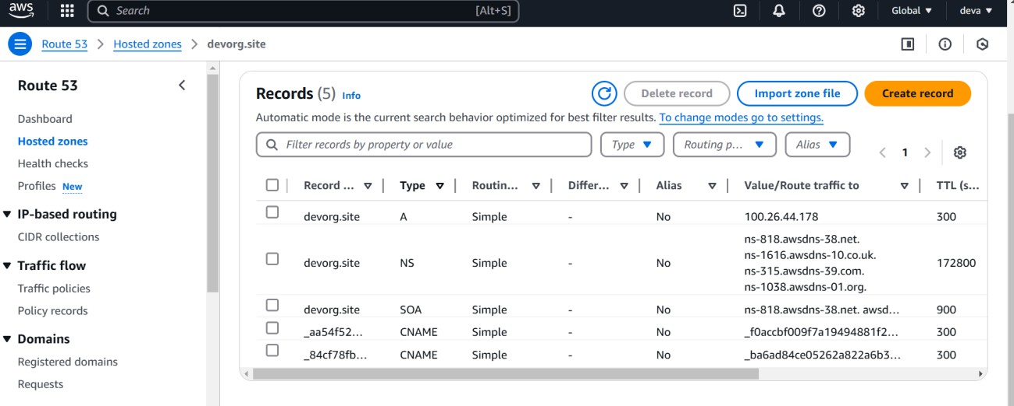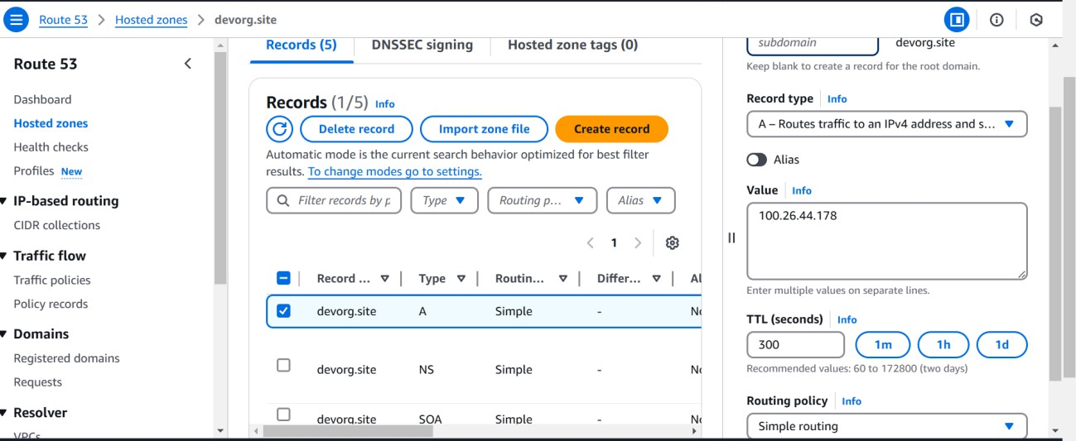

Hence this public ip is connected to my domain name (devorg.site) hence the route53 routes the traffic to the domain name.

1. **Monitoring the cloud watch logs for the code pipeline :**

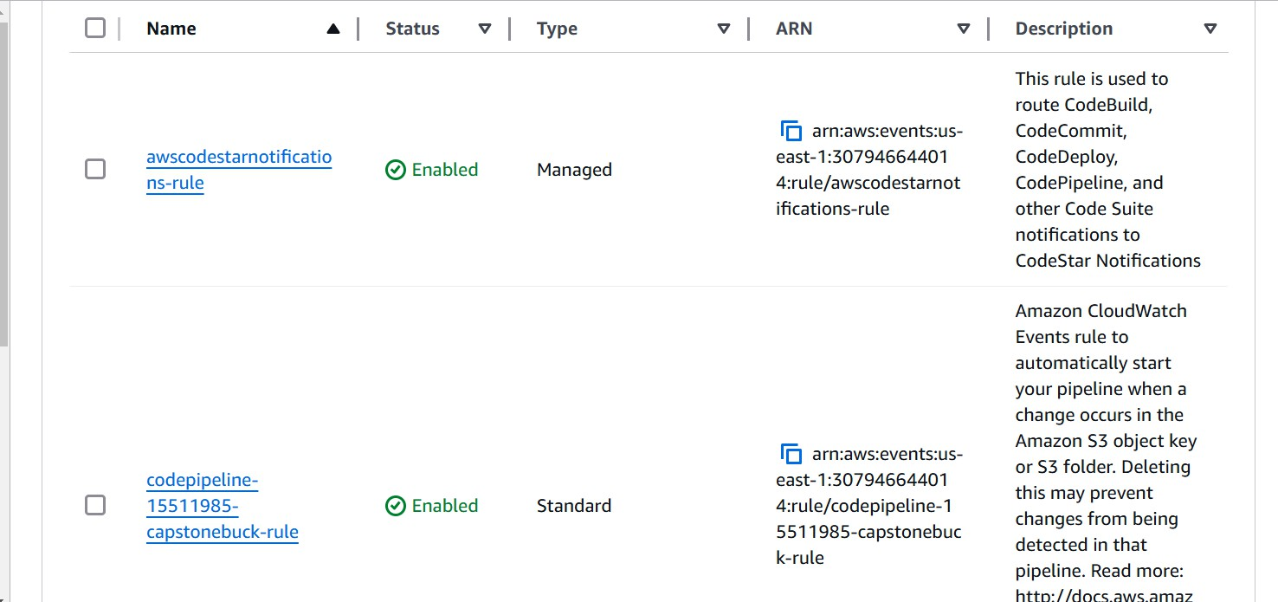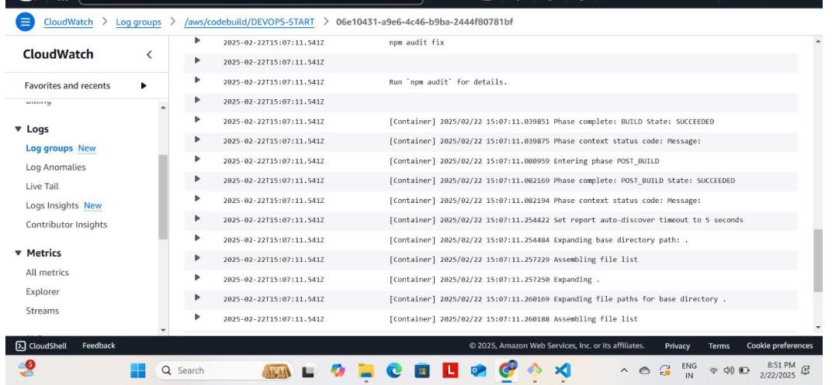

# Resources Used for This Project

* 1. **Amazon Official Documentation** – Used as the primary reference for setting up AWS CloudFormation templates, VPC configurations, EC2 instances, CodeDeploy, CodePipeline, Route 53, and Auto Scaling.
  2. **Google Resources** – Utilized for troubleshooting, exploring best practices, and finding alternative solutions for deployment and networking challenges.
  3. **Stack Overflow** – Referred to for resolving technical issues, debugging errors, and understanding implementation details from community experts.
  4. **Lucidchart** – Used for designing architecture diagrams, visualizing VPC networking, EC2 instance connections, and Blue-Green Deployment workflows.
  5. **Training Videos** – Followed AWS training and clasess to clarify doubts related to CloudFormation , CI/CD automation, and scaling strategies.

These resources collectively helped in planning, designing, and implementing an efficient and scalable infrastructure for the project.

# Conclusion:

This AWS-based Weather Application project successfully demonstrates the deployment of a scalable, automated, and highly available web application using AWS services. By leveraging **EC2 instances for hosting the frontend and backend, S3 for storage, RDS for database management, and Route 53 for domain routing**, we ensure seamless accessibility and performance. The integration of **Auto Scaling and Application Load Balancer (ALB)** enhances reliability by dynamically adjusting resources based on demand. Additionally, **CodeDeploy and CodePipeline automate deployment**, ensuring efficient updates with minimal downtime. This project showcases the power of AWS cloud infrastructure in building a robust and scalable weather application.